**Bukti Korespondesi Proses Review dan Bukti Revisi Selama Proses Review Jurnal Syarat Khusus untuk Jabatan Guru Besar**

**Nama : Dr. Ir. Gita Ciptaan, MP**

**NIP : 195911101986032003**

**NIDN : 0010115905**

**Unit Kerja : Fakultas Peternakan Universitas Andalas**

|  |  |  |
| --- | --- | --- |
| Judul artikel | : | The Effect of Fermented Palm Kernel Cake Layer Quail Rations on Production Performance and Eggshell Thickness |
| Nama Jurnal | : | International Journal of Veterinary Science |
| Vol/No/Hal/Tahun | : | 11(3): 400-403, 2022 |
| Publisher | : | Publisher USP (Unique Scientific Publishers) |
| SJR | : | 0,28 (Quartil Q3 bidang *veterinary* sejak 2020 hingga sekarang)  <https://www.scimagojr.com/journalsearch.php?q=21100820608&tip=sid> |
| Submitted | : | 07 September 2021 |
| Review report | : | 12 Oktober 2021 |
| Revised version | : | 13 Oktober 2021 |
| Accepted | : | 14 Oktober 2021 |
| Published | : | 01 Juni 2022 |

1. Tanggal 07 September 2021: artikel dikirim (submitted). Original paper terlampir.

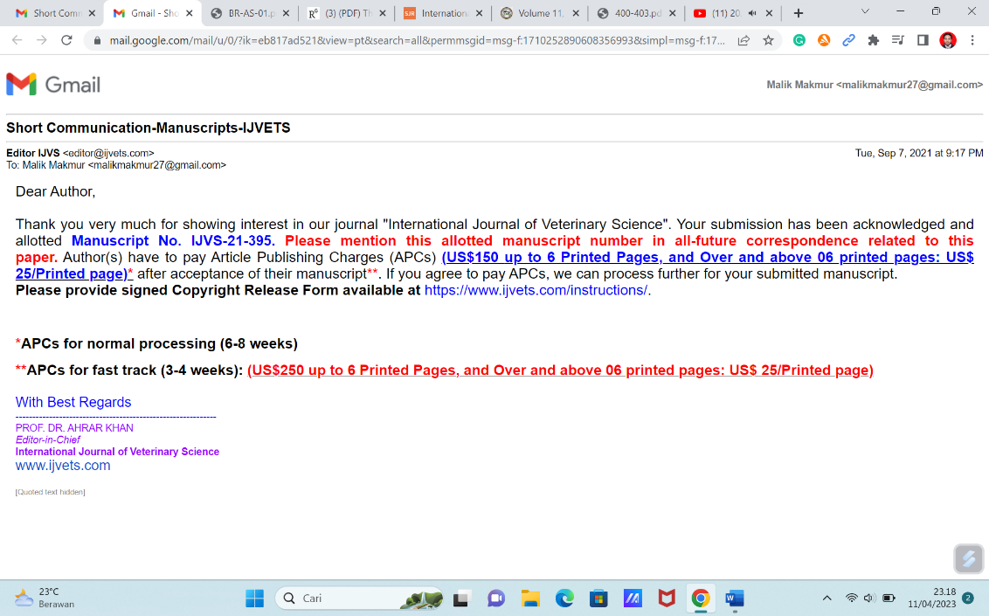

Gambar : Email Author’s Original Submission

1. Tanggal 09 September 2021: Pemberitahuan dan perbaikan hasil Turnitin paper

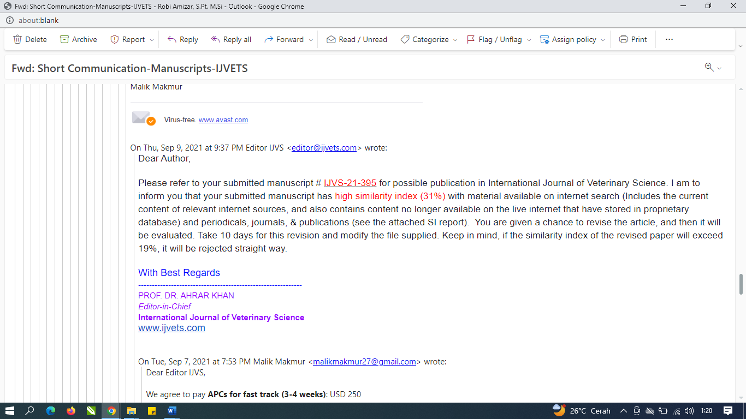

1. Tanggal 12 Oktober 2021: Pemberitahuan review pertama (I) dari Reviewer

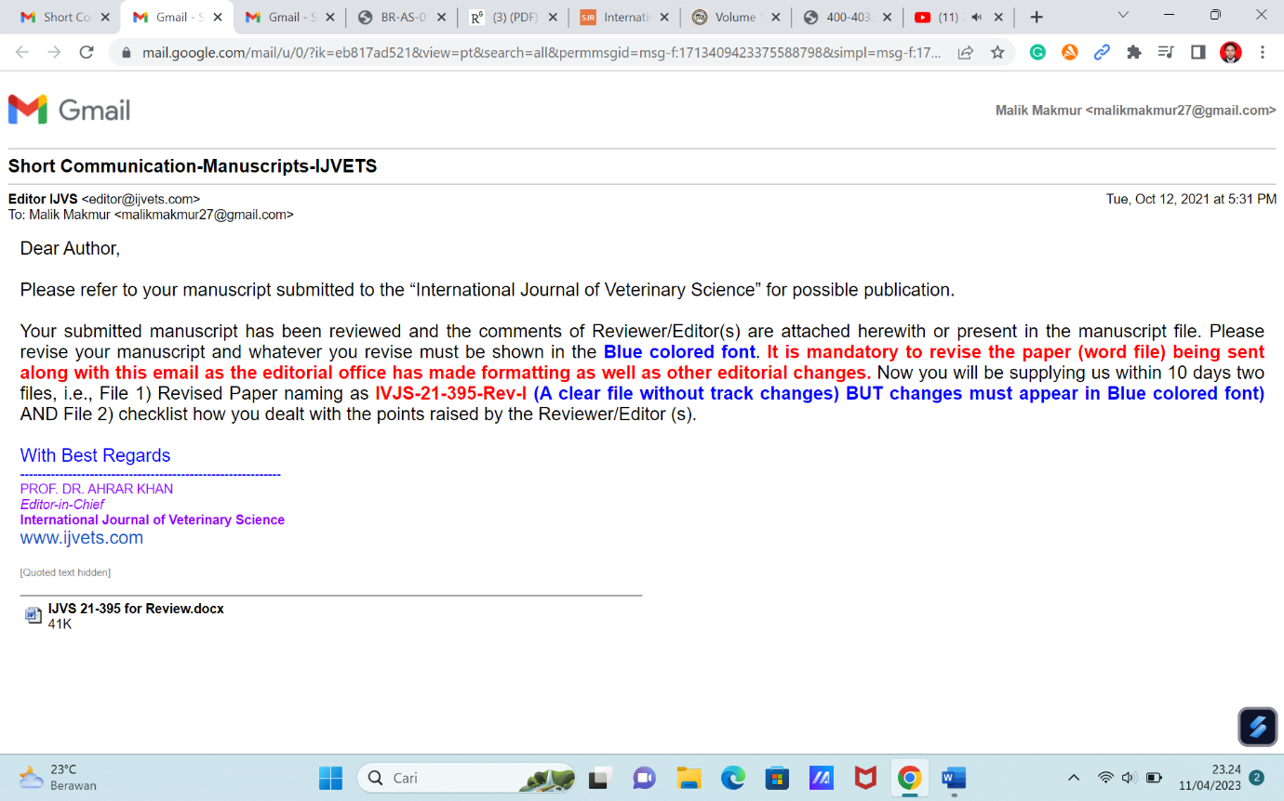 Gambar : Pemberitahuan dari editor tentang revisi pertama manuskrip

Catatan : Pengiriman “Summary of Modification” untuk menjawab hasil review (terlampir) ke dalam sistem jurnal secara langsung. Kemudian diikuti dengan membuat serta mengirim “revised Author Version” ke email editor (terlampir).

1. Tanggal 13 Oktober 2021: Penulis mengirim hasil perbaikan I (a revise author version)

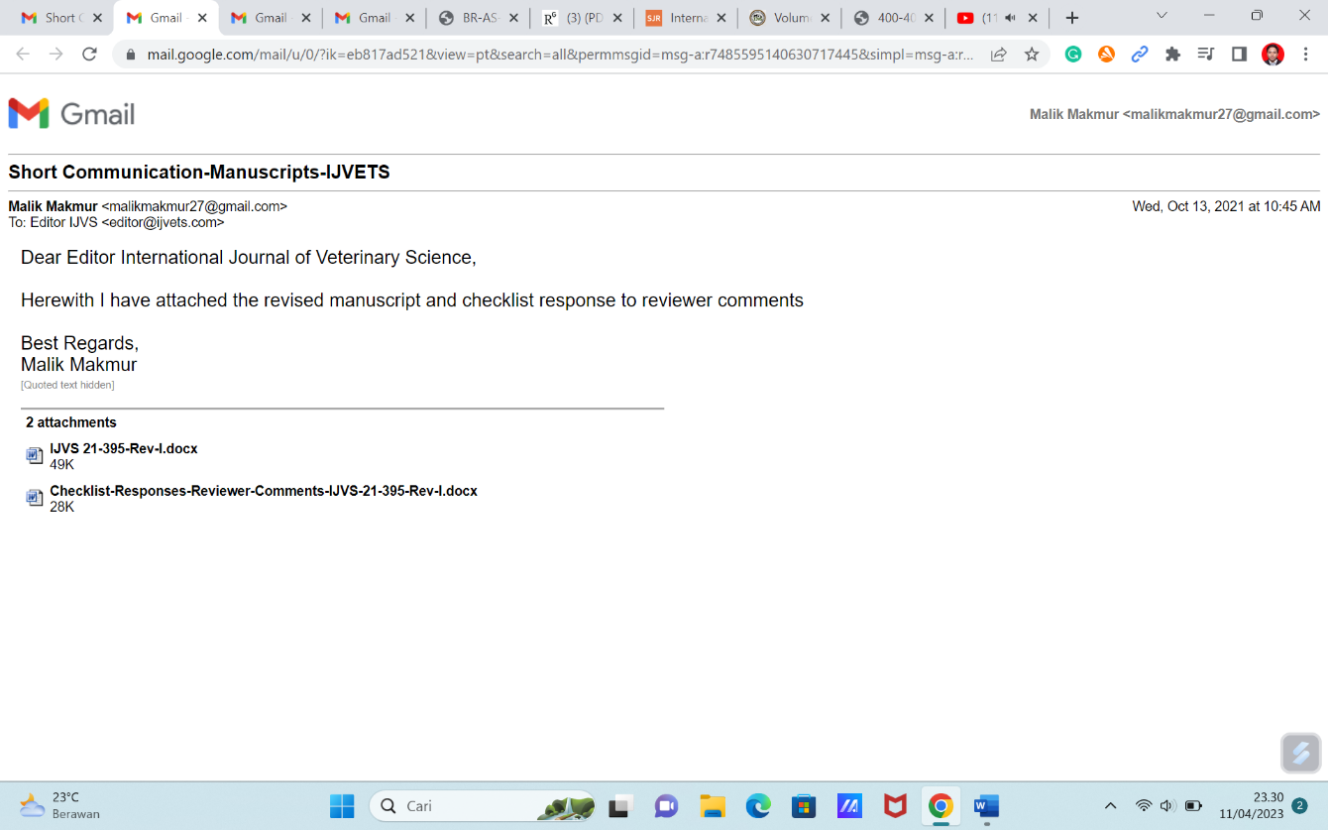

1. Tanggal 13 Oktober 2021 : Pemberitahuan Hasil review kedua (II) dari Reviewer.



1. Tanggal 14 Oktober 2021 : Pengiriman perbaikan (a revise author version II)



1. Tanggal 21 Oktober 2021 : Pemberitahuan Artikel di ***acceptance***.

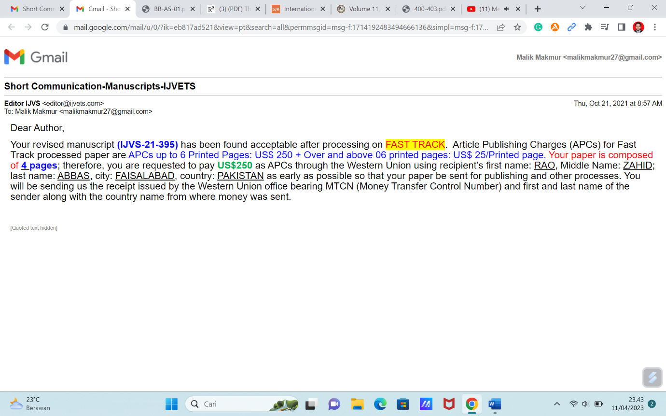

1. Tanggal 20 November 2021 : proses ***post-review*** manuskrip

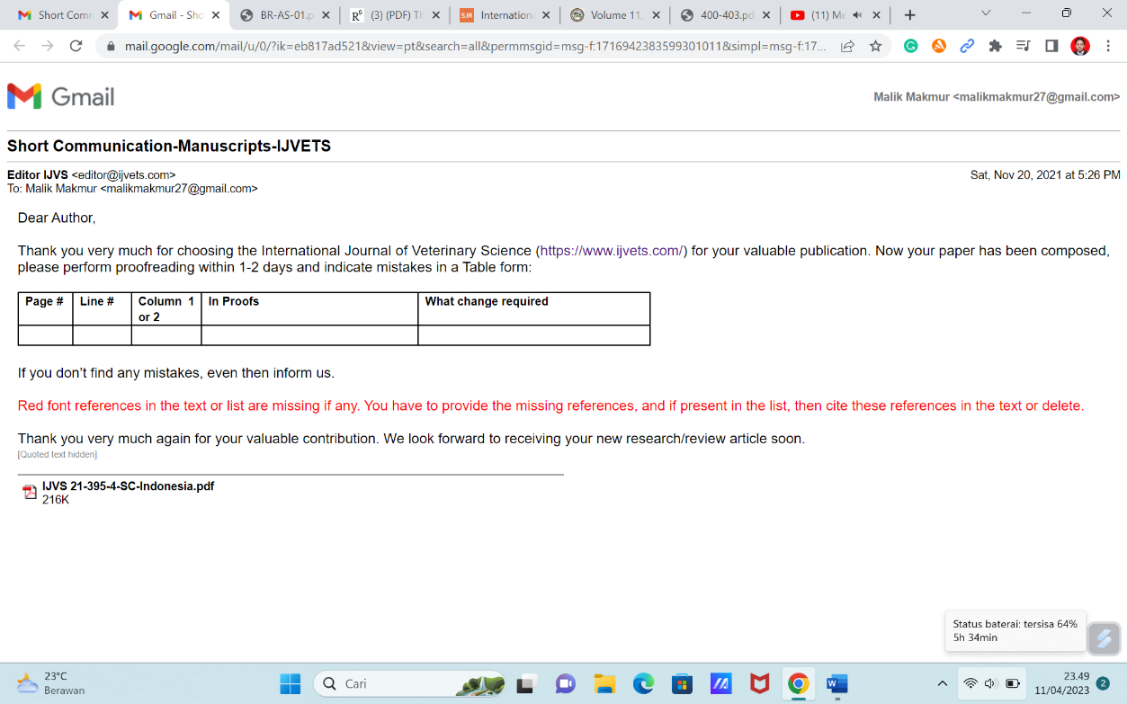

Lampiran Perbaikan (Revised) Post Review/ Proofread

|  |  |  |  |  |  |
| --- | --- | --- | --- | --- | --- |
| **No.** | **Page** | **Line** | **Column** | **In Proofs** | **What change required** |
| 1. | 1 | 9-10 | 1 | Doctoral Student, Department of Animal Nutrition and Feed Technology, Faculty of Animal Science, Andalas University,  10 Jl. Raya Unand, Kampus Limau Manis, Padang 25163, West Sumatera, Indonesia | Post-doctoral researcher, IPB University, Bogor, West Java, Indonesia |
| 2. | 1 | 46 | 2 | Mirnawati et al. (2017) | Mirnawati, Ciptaan G and Ferawati, 2017. The effect of mannanolytic fungi and humic acid dosage to improve the nutrient content and quality of fermented palm kernel cake. International Journal ChemTech Research 10: 56-61. |
| 3. | 2, 3 | 155, 172, 222 | 2, 1 | Mirnawati et al. (2019) | Mirnawati, Ciptaan G and Ferawati, 2019. Improving the quality and nutrient content of palm kernel cake through fermentation with *Bacillus subtilis*. Livestock Research for Rural Development 31: 2019. |
| 4. | 3 | 177 | 1 | Akbarillah et al. (2010) | Akbarillah T, Kususiyah and Hidayat, 2010. The effect of fresh indigofera leaves utilization as feed supplementation on egg production and its yolk color of ducks. Jurnal Sain Peternakan Indonesia 5: 27-33. <https://doi.org/10.31186/jspi.id.5.1.27-33> |
| 5. | 3 | 183 | 1 | needs of the birds These values | needs of the birds. These values |
| 6. | 3 | 241 | 2 | Sclerotium rolfsii | *Sclerotium rolfsii* |

1. 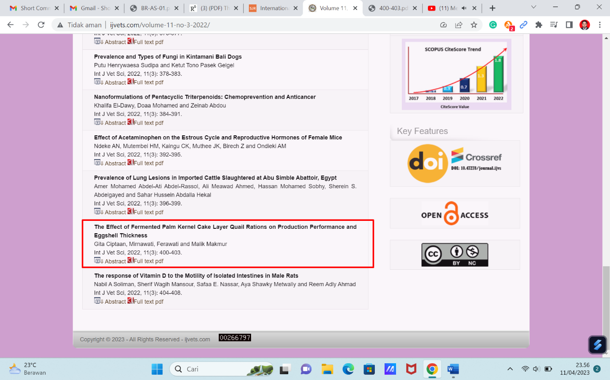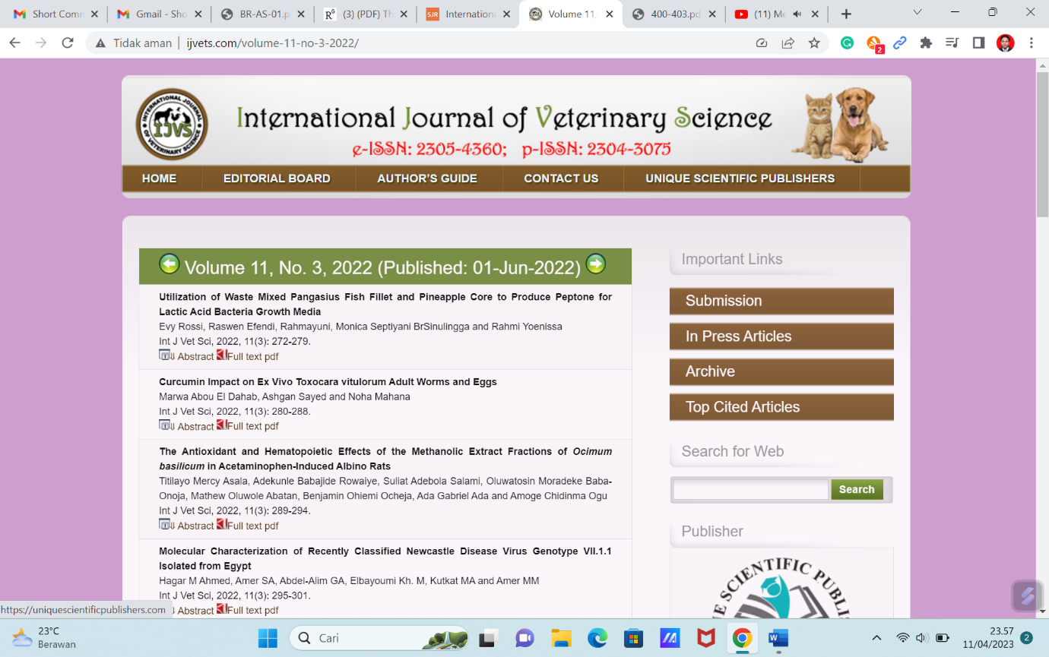Tanggal 01 Juni 2022 : Artikel Publish, tersedia online di International Journal of Veterinary Science

**MANUSKRIP VERSI PERTAMA**

**The effect of fermented palm kernel cake by adding humic acid in layer quail ration on production performance and eggshell thickness**

**Gita Ciptaan, Mirnawati, Ferawati and Malik Makmur1**

*Department of Animal Nutrition and Feed Technology, Faculty of Animal Science, Andalas University, Jl. Raya Unand, Kampus Limau Manis, Padang 25163, West Sumatera, Indonesia*

[*gciptaan@ansci.unand.ac.id*](mailto:gciptaan@ansci.unand.ac.id)

*1 Postgraduate Student, Department of Animal Nutrition and Feed Technology, Faculty of Animal Science, Andalas University, Jl. Raya Unand, Kampus Limau Manis, Padang 25163, West Sumatera, Indonesia*

**Abstract**

The experiment was conducted to evaluate the effect of palm kernel cake fermented with *Sclerotium rolfsii* added with humic acid in rations on production performance and quail egg quality. The material used in this study were two hundred layer quail with 14 weeks of age (*Coturnix coturnix japonica).* Research treatment were used fermented palm kernel cake (FPKC) with 0 %, 5 %, 10 %, 15% and 20% in ration composition. Feeding trial lasts for 8 weeks. Research method used completely randomized design with four replications. The results of this research showed that feed intake, egg production, feed conversion, egg weight and eggshell thickness of layer quail were non-significant (P>0.05). In conclusion, palm kernel cake fermented with *S. rolfsii* can be used up to 20% in laying quail ration.

***Keyword:*** egg quality, Japanese quail, palm kernel cake, *Sclerotium rolfsii*

**Introduction**

Palm kernel cake (PKC) is a by-product of palm oil processing that is potentially used as feedstuff for poultry. Seen from nutrient content of PKC as follows: crude protein 16.07%, crude fiber 21.30%, crude fat 8.23%, Ca 0.27% and P 0.94% and Cu 48.4 ppm (Mirnawati et al 2010). Although the crude protein content is quite high, but its use in poultry rations is still limited. According to Rizal (2000) get PKC can be used up to 10% or replace 40% of soybean meal in broiler ration. This is due to the high coarse fibers in β-manan (Sundu et al 2006). While poultry does not have fiber-breaking enzymes and manan in digestive tract. Therefore, it is necessary to process PKC first to improve its quality with fermentation biotechnology using cellulolitic and mananolitic molds (Meryandini et al 2008; Mirnawati et al 2018; Purwadaria and Haryati 2003) which can decrease the content of crude fiber and manan as well as the quality of palm kernel cake will be increased so that it can be replacing soybean meal in poultry rations.

Cellulolytic and mananolytic microbes which can be used for fermentation of palm kernel cake is *Sclerotium rolfsii*. Razak et al (2006) suggests that the manannase enzyme activity of *S*. *rolfsii* is higher than that of *Aspergilus niger.* fermentation of palm kernel cake with *S. rolfsii* has been carried out and gave the following results 26.90% crude protein, 54.86% nitrogen retention, 14.86% crude fiber, 58.41% crude fiber digestibility, 0.22% crude fat and 2557.6 kcal/kg. Although there is an increase in nutrient content and quality of palm kernel cake but its utilization in the ration is still limited 25% in broiler rations.

Mirnawati et al (2017) has been processing palm kernel cake with the addition of humic acid in the fermentation process with *S. rolfsii*. The results of this study showed an increase in nutrient content such as crude protein (27.43%), decreased crude fiber (11.53%), improving nitrogen retention (59.17%) and crude fiber digestibility (55.40%). The increasing of nutrient quality of palm kernel after fermentation is expected to be used as quail feed ingredients. Therefore, it is necessary to conduct research to determine the use of fermented palm kernel cake with *S. rolfsii* in rations on production performance and quality of laying quails.

**Materials and methods**

|  |  |  |  |  |  |
| --- | --- | --- | --- | --- | --- |
| **Table 1:** Diet formulation (%), nutrient content (%) and metabolizable energy (kcal/kg) | | | | | |
|  | **FPKC in diet (%)** | | | | |
| **0** | **5** | **10** | **15** | **20** |
| Corn | 45.5 | 45 | 44 | 43 | 43 |
| Rice brand | 20 | 18 | 16 | 13.5 | 11.5 |
| Meat meal | 6 | 6 | 6 | 6 | 6 |
| CP 126 concentrate | 26.5 | 24 | 22 | 20.5 | 17.5 |
| FPKC | 0 | 5 | 10 | 15 | 20 |
| Mineral | 1 | 1 | 1 | 1 | 1 |
| Top mix | 1 | 1 | 1 | 1 | 1 |
| Total (%) | 100 | 100 | 100 | 100 | 100 |
| Crude protein | 20.06 | 20.04 | 20.16 | 20.44 | 20.42 |
| Crude fat | 3.46 | 3.40 | 3.34 | 3.28 | 3.29 |
| Crude fiber | 6.13 | 6.17 | 6.23 | 6.27 | 6.50 |
| Calcium | 2.94 | 2.80 | 2.63 | 2.60 | 1.94 |
| Phosphor | 0.88 | 0.89 | 0.91 | 0.93 | 0.82 |
| Metabolizable energy | 2710 | 2708 | 2703 | 2706 | 2725 |

Two hundred for 14 weeks old quail laying were assigned this experiment. This laying quail was kept in individual cage (45 × 20 × 30 cm), there were 10 laying quail per unit of experiment. The experiment was performed in a completely randomized design (CRD) with five treatments (0, 5, 10, 15, and 20% FPKC) and four replicates. The diets were formulated in iso-protein 20% and iso-caloric 2700 kcal/kg ration. Diet formulation, nutrient and metabolizable energy contents of treatment diets were figured in Table 1. Diet formulation consists of yellow corn, rice bran, meat meal, CP 126 cocentrate feed (Charoen Pokphand Indonesia), top mix and FPKC. Experimental diet and drinking water were provided *ad-libitum.*

Palm kernel cake was the product of 80% PKC plus 20% rice bran that was fermented with *S*. *rolfsii* and addition of 200 ppm humic acid*.* The dose of inoculum that administered was 10% of substrate and incubated for7 days.After harvesting the product, FPKC then dried and milled then mixed in quail diets. Feeding period of layer quail lasts for two months or eight consecutive weeks. Details of feeding or diet treatment composition showed in Table 1.

Collected data were feed intake (g/head/day), quail day egg production (%), egg weight (g/egg/head), feed conversion, egg mass production (g/head/day) and eggshell thickness (mm) of laying quail were measured following Nuraini et al (2012). All of the data were analyzed by analysis of variance based on completely randomized design according to Steel and Torrie (1991).

|  |  |  |  |  |  |  |
| --- | --- | --- | --- | --- | --- | --- |
| **Table 2:** The effect of dietary fermented palm kernel cake (FPKC) on laying quail feed intake, egg production, egg mass, feed conversion, egg weight, and eggshell thickness | | | | | | |
|  | **FPKC in diet (%)** | | | | | **SEM** |
| **0** | **5** | **10** | **15** | **20** |
| Feed intake (g/head/day) | 20.37 | 21.61 | 21.71 | 21.47 | 22.30 | 0.43 |
| Egg production (%) | 71.80 | 71.61 | 70.80 | 72.05 | 70.93 | 2.01 |
| Egg mass (g/head/day) | 7.67 | 7.58 | 7.46 | 7.57 | 7.54 | 0.20 |
| Feed conversion ratio | 2.74 | 2.98 | 3.01 | 2.99 | 3.08 | 0.08 |
| Egg weight (g) | 10.69 | 10.61 | 11.71 | 10.48 | 10.65 | 0.50 |
| Eggshell thickness (mm) | 0.29 | 0.29 | 0.28 | 0.29 | 0.27 | 2.49 |

**Result**

The feed intake of laying quail was non significant (P>0.05) by the levels of FPKC in the diets. The increase in level of FPKC in the diets did not reduce feed consumption of laying quail. The feed intake was ranging from 20.37-22.30 g/head/day (Table 2).The feed consumption of quail laying was non-significant (P>0.05) by the levels of FPKC in diets.

The levels of FPKC in the diets were non-significant (P>0.05) on quail day egg production. The increase in levels of FPKC in quail diets maintaining egg production of laying quail. The egg production of quail laying of this experiment was ranging from 70.80 to 72.05%. Details

of quail day egg production showed in Table 2.

The egg mass production of quail laying was non-significant (P>0.05) by the levels of FPKC in diets. The egg mass production of laying quail in this experiment was ranging from 7.46 to 7.67 g/head/day during the experiment. In accordance with the opinion of Abou El-Ghar and Debes (2013); Vercese et al (2012), stated that egg mass is linked to egg weight and egg production pattern. This result is similar to Nuraini et al (2012), which gained egg mass in the range of 6.85-7.20 g/head/day by administering a mixture of sago pulp and tofu waste fermented with *Neurospora crassa* to level of 12% in ration. Ciptaan et al (2020) findings quail eggs mass is much lower by 6.11 g/head/day with a palm oil sludge fermented with *Phanerochaete chrysosporium and N. crassa* to 25% level in quail ration.

The feed conversion of laying quail was non-significant (P>0.05) by levels of FPKC in diets was ranging from 2.74-3.08. Feed conversion is ratio between feed consumption and egg mass so that if treatment of FPKC given does not affect feed consumption and egg mass, then ration conversion is also relatively same. In Table 1 can be seen that quail got ration containing FPKC up to 20% level is equally efficient in utilize ration so it can produce egg with same ration conversion with control ration. This shows that quail is equally efficient in rations containing FPKC.

The egg weight of laying quail was non-significant (P>0.05) by different levels of FPKC in rations. The egg weight of laying quail in this experiment was ranging from 10.61 to 11.71 g/egg/head.

The thicknesses of eggshell from laying quail was non-significant (P>0.05) by the levels of FPKC in diets. The eggshell thickness of laying quail in this experiment was ranging from 0.27 to 0.29 mm. Eggshell thickness treatment of control to 20% level in ration still gives almost equal value.

**Discussion**

The difference between the treatments of R1 to R5 on feed consumption of laying quail rations indicates that giving FPKC with *S. rolfsii* to 20% (R5) has the same palatability. These is the rations containing FPKC which have better quality and aroma than original substrate. In accordance with opinion Mirnawati et al (2018) states that fermentation process can provide advantages physical and chemical profiles such as aroma, taste, and texture better than original substrate. It was also reported that the amount of feed consumed by poultry is influenced by feed palatability, digestibility, and diet composition (Mirnawati et al 2019; Mirnawati et al 2020; Ciptaan et al 2020). In this study, age, type and energy and protein intake for quail are relatively equal. Ciptaan et al (2020) obtaining a quail feed intake of around 22.14 g/head/day by inclusion of palm oil sludge fermented with *P. chrysosporium* and *N. crassa* to 25% in ration.

Non-significant effect of the production of quail eggs in this study due means consumption of rations associated with egg production. Daily quail production in all treatment were not affected because fermentation of palm kernel cake provides sufficient nutrient for poultry production. Fermentation can improve digestibility, which is in accordance Sukaryana et al (2010), Dairo and Fasuyi (2008), Mirnawati et al (2013) and Mirnawati et al (2019) that agriculture waste treated with fermentation will have promising nutrient profiles. Akbarillah et al (2010) and Fajrona et al (2020) that egg production is influenced by the amount of food consumed, especially the consumption of nutrients in addition to environmental factors. Consumption is what underlies the formation of eggs both quantity and quality. Most nutrient consumption will be converted into eggs, in addition to the basic needs in poultry. This result is higher than previous study conducted by Ciptaan et al (2020), which recorded daily egg production 60.21% with a palm oil sludge fermented by *N. crassa* to 12% level in ration. The study conducted by Abbas et al (2016) showed feed intake rate of Japanese quail (7 weeks of age) which had been supplemented with 15 g/kg *Cucurbita moschata* seeds oil over a period of 1-3 weeks at 135.5 g.

Ration conversion value from this study is higher than Nuraini et al (2012), which recorded from 2.82 to 2.90 with a mixture of sago pulp and tofu waste fermented with *N*. *crassa* to 12% in ration. While this number is lower when compared with feed conversion value from quail ration with palm kernel cake fermented with *Bacillus subtilis* in level 25% ration (Fajrona et al 2020). Another by-product is palm oil sludge which has potential to substitute conventional feed ingredients (e.g. yellow corn and soybean meal) in poultry rations. Where previous studies did not show a significant difference in terms of feed conversion ratio of broilers (Mirnawati et al 2021). However, these results were better than addition of 200-600 mg/kg L-Carnitine to Japanese quail diet in feed conversion ratio at a range of 5.8-7.7 (Mahmoud et al 2020).

A slight difference in quail egg weight caused fermentation process can breaks down complex or low digestibility substances into simpler molecule structures so that can enhance nutrient absorption as well as quality of an poultry products. On the other hand, during an incubation process. microbes produce primary and secondary metabolites that have beneficial properties. In addition, Mirnawati et al (2019) showed fermented palm kernel meal has better amino acids quality after fermentation. The egg weight obtained from this study was higher than previous results obtained by Fajrona et al (2020) were 9.57 - 9.64 g/egg/head and Nuraini et al (2012) were reported at 10.29 g/egg/head.

Combination of FPKC and humic acid addition became mineral source also increase bioavailability of calcium and phospor, which is have important role for eggshell forming proccess. Enviromate (2002) stated that humic acid is a source of minerals and organic substances. Korsakov et al (2019) reported a significant effect on eggshell thickening (0.35 - 0.36 mm) of laying hens by administering humic acid (50-75 ml) via drinking water. Ciptaan et al (2020) obtained an average quail eggshell thickness of 0.26-0.28 mm. In addition Zita et al (2013), also states that average thickness of egg quail at 0.19 mm.

**Conclusion**

Based on result of this research, it can be concluded that palm kernel cake fermented with *Sclerotium rolfsii* can be used up to 20% level in quail rations. In terms of feed intake (22.30 g/head/day), egg production (70.93%), egg mass production (7.54 g/head/day), feed conversion (3.08), egg weight (10.65 g/egg/head), eggshell thickness (0.27 mm). It is hoped that palm kernel cake will be able to partially substitute commercial feed portions to enhance the profitability of quail layer farming.

**Acknowledgement**

This study was financially supported by BOPTN of Andalas University, number 42/UN.16.17/PP.RGB/LPPM/2019, dated April, 23rd 2019. I would like to thank all of those with whom I have had the pleasure to work during this project

**Conflict of interest**

All author declare that they have no conflict of interest.

**References**

**Abbas R J, Alshaheen S A and Majeed T I 2017** Evaluation of the productive and physiological performance of Japanese quail (*Coturnix coturnix japonica*) fed different levels of pumpkin (*Cucurbita moschata*) seeds oil. International Journal of Veterinary Science Vol. 6: 31-35.

**Abou El-Ghar R S and Debes A A 2013** Prediction of breeding values and selection for egg mass in a closed flock of white leghorn. International Journal of Livestock Production Research Vol. 1: 16-25.

**Canellas L P and Olivares F L 2014** Physiological responses to humic substances as plant growth promoter. Chemical and Biological Technologies in Agriculture 1: 3. <https://doi.org/10.1186/2196-5641-1-3>

**Ciptaan G, Mirnawati and Djulardi A 2020** Performance quality fed palm oil sludge fermented with *Phanerochaete crysosporium* and *Neurospora crassa*. Livestock Reasearch for Rural Development, Volume 32, Article #128. Retrieved September 1, 2021, from <http://www.lrrd.org/lrrd32/8/gcpt32128.html>

**Dairo F A S and Fauyi A O 2008** Evaluation of fermented palm kernel meal and fermented copra meal protein as substitute for soybean meal protein in laying hens diets. Journal Central European Agriculture Vol. 9: 35-44.

**Enviromate 2002** Effect of humic acid on animal and humans (literature review and current research), Effects of humic acid, Enviromate Inc. 8571. Boat Club Road, Forth Worth, Texas 76719.

**Fajrona K, Aini Q and Mirnawati 2020** The effect of fermented palm kernel cake with *bacillus subtilis*in rations on production performance and quail egg quality. Quest Journal of Research in Agriculture and Animal ScienceVol. 7: 6-10.

**Korsakov K V, Vasiliev A A, Sivokhina L A, Zabelina M V, Murtazaeva R N, Daeva T V and Kokorev V A 2019** The influence of humic acid supplement on the marketable properties of hy-line laying hen eggs. Advances in Animal and Veterinary Sciences Vol. 7: 66-70. <http://dx.doi.org/10.17582/journal.aavs/2019/7.s1.66.70>

**Mahmoud R E, Elshopakey G E and Awadin W F 2020** Effects of feeding diets supplemented with different levels of l-carnitine on growth performance, serum metabolites, histopathological changes in growing japanese quails. International Journal of Veterinary Science Vol. 9: 16-23.

**Meryandini A, Angreandari R and Rahmania N 2008** Isolasi bakteri mananolitik dan karakterisasi mananasenya. Biota Vol. 13: 82-88. <https://doi.org/10.24002/biota.v13i2.2675>

**Mirnawati, Ciptaan G and Ferawati 2019** Improving the quality and nutrient content of palm kernel cake through fermentation with *Bacillus subtilis*. Livestock Research for Rural Development, Volume 31, Article #98. Retrieved September 2, 2021, from <http://www.lrrd.org/lrrd31/7/mirna31098.html>

**Mirnawati, Ciptaan G and Ferawati 2020** Broiler performance on a diet containing palm kernel meal fermented with *Bacillus subtilis*. Livestock Research for Rural Development, Volume 32, Article #21. Retrieved September 2, 2021, from <http://www.lrrd.org/lrrd32/2/mirna32021.html>

**Mirnawati, Ciptaan G, Djulardi A and Makmur M 2021** Broiler response to the utilization of fermented palm oil sludge with *Phanerochaeta chrysosporium* and *Neurospora crassa*. International Journal of Veterinary Science. In press article. <https://doi.org/10.47278/journal.ijvs/2021.089>

**Mirnawati, Djulardi A and Ciptaan G 2018** Utilization of fermented palm kernel cake with *Sclerotium rolfsii* in broiler ration. International Journal of Poultry Science Vol. 17 : 342-347. <https://dx.doi.org/10.3923/ijps.2018.342.347>

**Mirnawati, Rizal Y and Marlida Y 2013** Effect of humic acid addition via drinking water on the performance of broiler fed diet containing fermented and non fermented palm kernel cake. Archiva Zootechnica Vol. 16: 41-53.

**Nuraini, Sabrina and Latif S A 2012** Performances and quail egg quality feeding product fermented with *Neurospora crassa*. Indonesian Journal of Animal Science Vol. 14: 385-391. <https://doi.org/10.25077/jpi.14.2.385-391.2012>

**Purwadaria T and Haryati T 2003** *In vitro* digestibility evaluation of coconut meal incorporated precipitate Beta D Manannase from *Eupenicillium javanicum*. Journal Microbiology Indonesia, Vol. 2003: 19 -21.

**Razak N A 2006** Production and purification of mannanase degrading enzymes from palm kernel cake fermented by *Aspergillus niger* and *Sclerotium rolfsii*. Master thesis Universiti Putra Malaysia, Malaysia.

**Rizal Y 2000** The response of broiler to the substitution part of soybean meal for palm kernel cake in the diet. Jurnal Peternakan Lingkungan Vo. 2: 15-20.

**Steel R G D and Torrie J H 1991** Prinsip and Prosedur Statistik: Suatu pendekatan Biometrik PT. Gramedia Pustaka Utama. Jakarta, Indonesia.

**Sukaryana Y, Atmomarsono U, Yunianto V D and Supriatna E 2010** Bioconversions of palm kernel cake and rice bran mixture by *Trichoderma viridae* toward nutritional contents. International Journal of Science and Engineering Vol. 1: 27 - 32. <http://dx.doi.org/10.12777/ijse.1.2.27-32>

**Sundu B, Kumar A and Dingle J 2006** Palm kernel meal in broiler diets:effect on chicken performance and health. World’s Poultry Science Journal Vol. 62 316-325. <https://doi.org/10.1079/WPS2005100>

**Vercese F, Garcia E A, Sartori J R, Silva Ade P, Faitarone A B G, Berto D A, Molino A de B and Pelícia K 2012** Performance and egg quality of Japanese quails submitted to cyclic heat stress. Brazilian Journal Poultry Science Vol. 14: 37-41. <https://doi.org/10.1590/S1516-635X2012000100007>

**Zita L, Ledvinka Z and Klesalova L 2013** The effect of the age of Japanese quails on certain egg quality traitsand their relationship. Veterinary Archives Vol. 83: 223-232.

**MANUSKRIP REVISI I**

**The Effect of Fermented Palm Kernel Cake Layer Quail Rations on Production Performance and Eggshell Thickness**

**ABSTRACT**

The purpose of the study was to evaluate how palm kernel cake fermented by *Sclerotium rolfsii* and supplemented with humic acid affected production performance and egg quality of quails. The animals used in this study were 200 layer quail (*Coturnix coturnix japonica*) at 14 weeks of age. Fermented palm kernel cake (FPKC) with rationed compositions of 0%, 5%, 10%, 15%, and 20% were utilised in the research treatment, which lasted for eight weeks. Also, this study used a randomised design with four replicates in each group. The results showed that feed intake, egg production, feed conversion, egg weight, and eggshell thickness of layer quail were not statistically significant (P>0.05). Conclusively, palm kernel cake fermented with *S. rolfsii* may be utilised in laying quail feed at a concentration of up to 20%.

**Key words:** Egg quality, Humic acid, Japanese quail, Palm kernel cake, *Sclerotium rolfsii*

**INTRODUCTION**

Palm kernel cake (PKC) is a by-product of palm oil processing, which can serve as a potential ingredient in poultry feed. Furthermore, its nutritional composition includes crude protein, crude fibre, crude fat, calcium, phosphorus at 16.07 %, 21.30 %, 8.23 %, 0.27 %, and 0.94 %, respectively, as well as copper at 48.4 ppm. (Mirnawati et al. 2010). The crude protein content of PKC is relatively high, yet its use in poultry rations is still limited. According to Rizal (2000), PKC at a concentration of up to 10 % can be used instead of 40 % soybean meal in broiler diet due to the high β-Manan content in the coarse fibres, which may be undesirable since birds do not have fibre-breaking enzymes for manan in the digestive tract (Sundu et al. 2006). Therefore, PKC must first be processed to improve its quality with the aid of fermentation biotechnology that utilises cellulolytic and mannanolytic moulds (Meryandini et al. 2008; Mirnawati et al. 2018; Purwadaria and Haryati., 2003). Furthermore, this can reduce the content of crude fibre and manan while increasing the quality of palm kernel cake such that it can replace the soybean meal in poultry rations.

*Sclerotium rolfsii* is a cellulolytic and mannanolytic microorganism that can be used for the fermentation of palm kernel cake. According to Razaket al. (2006), the mannanase enzyme activity of *S. rolfsii* is greater than that of *Aspergillus niger*. The fermentation of palm kernel cake with *S. rolfsii* yielded crude protein, retained nitrogen, crude fibre, and digestible crude fibre at 26.90%, 54.86%, 14.86%, and 58.41%, respectively, as well as crude fat at 0.22% and 2557.6 kcal/kg. However, the use of palm kernel cake in broiler diets is still restricted to 25% despite the rise in its nutritional content and quality.

Mirnawati et al. (2017) processed palm kernel cake mixed with humic acid through the fermentation process using S. rolfsii. The result of this study showed an increase in crude protein, nitrogen retention, and crude fibre digestibility at 27.43 %, 59.17 %, and 55.40 %, respectively, as well as a decrease in crude fibre at 11.53 %. After fermentation, the increased nutritional content of palm kernels enables its use as a quail feed ingredient. Therefore, it is necessary to conduct research in order to determine the effect of fermented palm kernel cake containing *S. rolfsii* in rations on the production performance and quality of laying quails.

**MATERIALs AND METHODS**

The samples used in this study were 200 quail laying hens aged about 14-weeks old, which were confined in individual cages of size 45 × 20 × 30 cm as ten laying birds per unit. The study used a fully randomized design (CRD) with five treatments containing 0, 5, 10, 15, and 20% compositions of FPKC, as well as four replicates each. The diets used included iso-protein and iso-caloric at 20% and 2700 kcal/kg, respectively. Subsequently, Table 1 showed the diet formulation, nutritional and metabolizable energy levels of treatment diets. The diet formulation was made up of yellow corn, rice bran, meat meal, CP 126 concentrate feed (Charoen Pokphand Indonesia), top mix and FPKC. In addition, drinking water and experimental diet were provided *ad-libitum.*

The fermented palm kernel cake was made using a combination of PKC and rice bran at 80 % and 20 %, respectively, which were fermented with *S. rolfsii* and added to 200 ppm humic acid. The inoculum dosage was 10% of the substrate, and the incubation period was seven days. After harvesting, the product is dried and milled before being incorporated into quail diets. Meanwhile, layer quail have a feeding period of two months or eight weeks. Table 1 showed the composition of the feeding or diet treatments.

**Data Collection**

The data collected during the study included feed conversion, egg mass production (g/head/day), egg weight (g/egg/head), feed intake (g/head/day), quail day egg production (%) and the eggshell thickness (mm) of laying quail, which were measured following Nuraini et al. (2012).

**Data Analysis**

All data were analyzed by analysis of variance based on a completely randomized design according to Steel and Torrie (1991).

**RESULTS**

There was no significant difference (P>0.05) in the feed intake of the laying quails based on the levels of FPKC in the diets since an increase in the level of FPKC did not reduce the feed consumption of the laying quails. Table 2 showed the feed intake, which ranged between 20.37-22.30 g/head/day. Similarly, there was no significant difference (P>0.05) in the feed consumption of the laying quails based on the levels of FPKC in the diets.The effects of the amount of FPKC in the diet on the daily egg production of quails were not significant (P>0.05). However, increased amounts of FPKC in quail diets can sustain the egg production of laying quails. The egg production of laying quails in this experiment ranged between 70.80 to 72.05 %, as shown in Table 2.

The quantity of FPKC in meals did not affect egg mass production of laying quails (P>0.05). During the trial, the egg mass output of laying quails ranged from 7.46 to 7.67 g/head/day. Feed conversion is the ratio of feed intake to egg mass, and it was non-significant (P>0.05) when FPKC levels in diets ranged between 2.74-3.08. Different amounts of FPKC in diets had no effect on the egg weight of laying quail (P>0.05), which ranged from 10.61 to 11.71 g/egg/head. The amounts of FPKC in meals had no effect on the thickness of the eggshells from laying quails (P>0.05), which ranged from 0.27 to 0.29 mm.

**DISCUSSION**

The difference in feed consumption of laying quail rations between treatments R1 and R5 suggests that feeding FPKC with *S. rolfsii* to 20% (R5) has the same palatability. However, these FPKC-containing meals were discovered to have a higher quality and aroma than the original substrate. According to Mirnawati et al. (2018), the fermentation process can improve the physical and chemical characteristics such as aroma, taste, and texture compared to the original substrate. Furthermore, it was also observed that feed palatability, digestibility, and diet composition all affect the amount of feed eaten by birds (Mirnawati et al. 2019; Mirnawati et al. 2020; Ciptaan et al. 2020). In this study, parameters such as age, type, as well as energy and protein consumption were all relatively equal. Ciptaan et al. (2020) obtained a quail feed intake of about 22.14 g/head/day by adding 25 % palm oil sludge fermented with *Phanerochaeta chrysosporium* and *Neurospora crassa* in rations. Palm oil sludge is another promising by-product that can replace the ingredients of standard feed, such as yellow maize and soybean meal, in poultry diets. Previous research did not reveal a significant difference in the feed conversion ratio of broilers (Mirnawati et al. 2021).

The daily quail production was unaffected in treatments R1, R2, R3, R4, and R5 since fermented palm kernel cake provides enough nutrients needed for poultry production. Subsequently, fermentation can increase digestibility, which is in line with the hypothesis of Sukaryana et al. (2010), Dairo and Fasuyi (2008), Mirnawati et al. (2013), and Mirnawati et al. (2019) that fermented farm waste will have favourable nutritional profiles. Meanwhile, there was no significant difference in the egg production of quails since it was associated with the consumption of rations. This is consistent with the study by Akbarillah et al. (2010) and Fajrona et al. (2020) that egg production is controlled by the amount of food ingested, particularly nutrient consumption, as well as environmental variables. onsumption is improves the quantity and quality of egg production since a majority of the nutrients consumed will be transformed into eggs, in addition to the fundamental needs of the birds  This values obtained in this result is greater than what was obtained in the previous study by Ciptaan et al. (2020), which reported daily egg production of 60.21 % using palm oil sludge fermented with *N. crassa* at a ration level of 12 %. According to a study by Abbas et al. (2016), the rate of feed intake Japanese quails at seven weeks of age, supplemented with 15 g/kg *Cucurbita moschata* seeds oil over a period of 1-3 weeks, was 135.5 g.

According to Abou El-Ghar and Debes (2013) and Vercese et al. (2012), egg mass is related to egg weight and egg production pattern. This is comparable to the results obtained by Nuraini et al. (2012), who obtained an egg mass in the range of 6.85-7.20 g/head/day by administering a mixture of sago pulp and tofu waste fermented with *N. crassa* at a 12 % ration. According to Ciptaan et al. (2020), the quail egg mass was reduced by 6.11 g/head/day when palm oil sludge fermented with *P. chrysosporium* and *N. crassa*, was incorporated to quail feed at a 25 % ration level.

The FPKC treatment has no effect on feed consumption or egg mass, the ration conversion is also relatively the same. Table 1 shows that quails fed a ration containing up to 20% FPKC are similarly efficient in egg production to quails fed with the control ration (R1), which demonstrates that quails are equally efficient in FPKC-containing diets.

The result of this study is greater than that obtained by Nuraini et al*.* (2012), which utilised ration conversions ranging from 2.82 to 2.90 with a mixture of sago pulp and tofu pulp fermented with *N. crassa* 12% in rations. This figure is lower when compared to the feed conversion value from quail ration with palm kernel cake fermented with *Bacillus subtilis* at a 25% ration level. (Fajrona et al. 2020). However, The results were more desirable than what was obtained from a mixture of 200-600 mg/kg L-Carnitine and Japanese quail diet with a feed conversion ratio ranging between 5.8 to 7.7 (Mahmoud et al. 2020).

A minor variation in quail egg weight produced by the fermentation process might break down complex or low digestible components into simpler molecular structures, improving nutritional absorption and the quality of poultry products. Conversely, beneficial primary and secondary metabolites are secreted by microbes throughout the incubation process. Furthermore, Mirnawati et al. (2019) showed that fermented palm kernel meal has higher amino acid quality after fermentation. The egg weight obtained from this study was higher than previous results obtained by Fajrona et al. (2020) and Nuraini et al. (2012), which were 9.57 - 9.64 g/egg/head and 10.29 g/egg/head, respectively.

The eggshell thickness treatment of R1 to R5 showed that FPKC up to 20% in the diet still provides almost similar results because the inclusion of FPKC and humic acid as mineral sources increases the bioavailability of calcium and phosphorus, both of which play significant roles in the eggshell formation process. According to Enviromate (2002), humic acid is a source of minerals and organic compounds. Also, Korsakov et al. (2019) found that about 50-75 ml of humic acid given through drinking water significantly affects the eggshell thickness, which was 0.35 - 0.36 mm in laying hens. Ciptaan et al. (2020) measured the average thickness of quail eggshells to be 0.26-0.28 mm. Additionally, Zita et al. (2013), also reported that the average thickness of quail eggs was 0.19 mm.

**Conclusion**

Conclusively, palm kernel cake fermented with Sclerotium rolfsii can be utilized up to 20% in quail diets. The results showed that the feed intake, egg production, egg mass production, feed conversion, egg weight, and eggshell thickness were found to be 22.30 g/head/day, 70.93%, 7.54 g/head/day, 3.08, 10.65 g/egg/head, and 0.27 mm, respectively. Therefore, it is expected that palm kernel cake would be able to partially replace the current ingredients used in commercial feed in order to enhance the profitability of quail layer farming.

**Acknowledgements**

This study was funded by the BOPTN of Andalas University, number 42/UN.16.17/PP.RGB/LPPM/2019, on the 23rd of April, 2019. I am grateful to everyone with whom I had the pleasure of working on this project.

**Author’s Contribution**

Gita Ciptaan supervised the experiment and writing original manuscript. Mirnawati and Ferawati conducted the experiment and analyzed the data. Malik Makmur finalize manuscript.

**REFERENCES**

Abbas RJ, Alshaheen SA and Majeed TI, 2017. Evaluation of the productive and physiological performance of Japanese quail (*Coturnix coturnix japonica*) fed different levels of pumpkin (*Cucurbita moschata*) seeds oil. International Journal of Veterinary Science 6: 31-35.

Abou El-Ghar RS and Debes AA, 2013. Prediction of breeding values and selection for egg mass in a closed flock of white leghorn. International Journal of Livestock Production Research 1:16-25.

Canellas LP and Olivares, FL, 2014. Physiological responses to humic substances as plant growth promoter. Chemical and Biological Technologies in Agriculture 1: 3. <https://doi.org/10.1186/2196-5641-1-3>

Ciptaan G, Mirnawati and Djulardi A, 2020. Performance quality feed palm oil sludge fermented with *Phanerochaete crysosporium* and *Neurospora crassa*. Livestock Reasearch for Rural Development 32: 8.

Dairo FAS and Fauyi AO, 2008. Evaluation of fermented palm kernel meal and fermented copra meal protein as substitute for soybean meal protein in laying hens diets. Journal Central European Agriculture 9: 35-44.

Enviromate, 2002. Effect of humic acid on animal and humans (literature review and current research), Effects of humic acid, Enviromate Inc. 8571. Boat Club Road, Forth Worth, Texas 76719.

Fajrona K, Aini Q and Mirnawati, 2020. The effect of fermented palm kernel cake with *bacillus subtilis*in rations on production performance and quail egg quality. Quest Journal of Research in Agriculture and Animal Science7: 6-10.

Korsakov KV, Vasiliev AA, Sivokhina LA,Zabelina MV, Murtazaeva RN, Daeva TV and Kokorev VA, 2019. The influence of humic acid supplement on the marketable properties of hy-line laying hen eggs. Advances in Animal and Veterinary Sciences 7: 66-70. <http://dx.doi.org/10.17582/journal.aavs/2019/7.s1.66.70>

Mahmoud RE, Elshopakey GE and Awadin WF, 2020. Effects of feeding diets supplemented with different levels of l-carnitine on growth performance, serum metabolites, histopathological changes in growing japanese quails. International Journal of Veterinary Science 9: 16-23.

Meryandini A, Angreandari R and Rahmania N, 2008. Isolasi bakteri mananolitik dan karakterisasi mananasenya. Biota 13: 82-88. <https://doi.org/10.24002/biota.v13i2.2675>

Mirnawati, Ciptaan G and Ferawati, 2019. Improving the quality and nutrient content of palm kernel cake through fermentation with *Bacillus subtilis*. Livestock Research for Rural Development 31: 119-123.

Mirnawati, Ciptaan G and Ferawati, 2020. Broiler performance on a diet containing palm kernel meal fermented with *Bacillus subtilis*. Livestock Research for Rural Development 32: 2020.

Mirnawati, Ciptaan G, Djulardi A and Makmur M, 2021. Broiler response to the utilization of fermented palm oil sludge with *Phanerochaeta chrysosporium* and *Neurospora crassa*. International Journal of Veterinary Science. In press article. <https://doi.org/10.47278/journal.ijvs/2021.089>

Mirnawati, Djulardi A and Ciptaan G, 2018. Utilization of fermented palm kernel cake with *Sclerotium rolfsii* in broiler ration. International Journal of Poultry Science 17 : 342-347. <https://dx.doi.org/10.3923/ijps.2018.342.347>

Mirnawati, Rizal Y and Marlida Y, 2013. Effect of humic acid addition via drinking water on the performance of broiler fed diet containing fermented and non fermented palm kernel cake. Archiva Zootechnica 16: 41-53.

Nuraini, Sabrina and Latif SA, 2012. Performances and quail egg quality feeding product fermented with *Neurospora crassa*. Indonesian Journal of Animal Science 14: 385-391. <https://doi.org/10.25077/jpi.14.2.385-391.2012>

Purwadaria T and Haryati T, 2003. *In vitro* digestibility evaluation of coconut meal incorporated precipitate Beta D Manannase from *Eupenicillium javanicum*. Journal Microbiology Indonesia, 2003: 19 -21.

Razak NA, 2006. Production and purification of mannanase degrading enzymes from palm kernel cake fermented by *Aspergillus niger* and *Sclerotium rolfsii*. Master thesis Universiti Putra Malaysia, Malaysia.

Rizal Y, 2000. The response of broiler to the substitution part of soybean meal for palm kernel cake in the diet. Jurnal Peternakan Lingkungan 2: 15-20.

Steel RGD and Torrie JH, 1991. Prinsip and Prosedur Statistik: Suatu pendekatan Biometrik PT. Gramedia Pustaka Utama. Jakarta, Indonesia.

Sukaryana Y, Atmomarsono U, Yunianto VD and Supriatna E, 2010. Bioconversions of palm kernel cake and rice bran mixture by *Trichoderma viridae* toward nutritional contents. International Journal of Science and Engineering 1: 27 - 32. <http://dx.doi.org/10.12777/ijse.1.2.27-32>

Sundu B, Kumar A and Dingle J, 2006 Palm kernel meal in broiler diets:effect on chicken performance and health. World’s Poultry Science Journal 62 316-325. <https://doi.org/10.1079/WPS2005100>

Vercese F, Garcia EA, Sartori JR, Silva Ade P, Faitarone ABG, Berto DA, Molino A de B and Pelícia K, 2012. Performance and egg quality of Japanese quails submitted to cyclic heat stress. Brazilian Journal Poultry Science 14: 37-41. <https://doi.org/10.1590/S1516-635X2012000100007>

Zita L, Ledvinka Z and Klesalova L, 2013. The effect of the age of Japanese quails on certain egg quality traitsand their relationship. Veterinary Archives. 83: 223-232.

**Table 1:** Diet formulation (%), nutrient content (%) and metabolizable energy (kcal/kg).

|  |  |  |  |  |  |
| --- | --- | --- | --- | --- | --- |
| **Item** | **Treatment Ration** | | | | |
| **R1** | **R2** | **R3** | **R4** | **R5** |
| Corn | 45.5 | 45 | 44 | 43 | 43 |
| Rice brand | 20 | 18 | 16 | 13.5 | 11.5 |
| Meat meal | 6 | 6 | 6 | 6 | 6 |
| CP 126 concentrate | 26.5 | 24 | 22 | 20.5 | 17.5 |
| FPKC | 0 | 5 | 10 | 15 | 20 |
| Mineral B12 | 1 | 1 | 1 | 1 | 1 |
| Top mix | 1 | 1 | 1 | 1 | 1 |
| Total (%) | 100 | 100 | 100 | 100 | 100 |
| Crude protein | 20.06 | 20.04 | 20.16 | 20.44 | 20.42 |
| Crude fat | 3.46 | 3.40 | 3.34 | 3.28 | 3.29 |
| Crude fiber | 6.13 | 6.17 | 6.23 | 6.27 | 6.50 |
| Calcium | 2.94 | 2.80 | 2.63 | 2.60 | 1.94 |
| Phosphor | 0.88 | 0.89 | 0.91 | 0.93 | 0.82 |
| Metabolizable energy | 2710 | 2708 | 2703 | 2706 | 2725 |

**Table 2:** The effect of dietary fermented palm kernel cake (FPKC) on laying quail feed intake, egg production, egg mass, feed conversion, egg weight, and eggshell thickness.

|  |  |  |  |  |  |  |
| --- | --- | --- | --- | --- | --- | --- |
| **Variables** | **Treatment (%)** | | | | | **SEM** |
| **R1** | **R2** | **R3** | **R4** | **R5** |
| Feed intake (g/head/day) | 20.37 | 21.61 | 21.71 | 21.47 | 22.30 | 0.43 |
| Egg production (%) | 71.80 | 71.61 | 70.80 | 72.05 | 70.93 | 2.01 |
| Egg mass (g/head/day) | 7.67 | 7.58 | 7.46 | 7.57 | 7.54 | 0.20 |
| Feed conversion ratio | 2.74 | 2.98 | 3.01 | 2.99 | 3.08 | 0.08 |
| Egg weight (g) | 10.69 | 10.61 | 11.71 | 10.48 | 10.65 | 0.50 |
| Eggshell thickness (mm) | 0.29 | 0.29 | 0.28 | 0.29 | 0.27 | 2.49 |

Note: Inclusion FPKC in R1 to R5 was R1 (0%-Control), R2 (5%), R3 (10%), R4 (15%), and R5(20%). SEM: standard error of the mean.

**MANUSKRIP REVISI II**

**Short Communication**

**The Effect of Fermented Palm Kernel Cake LayerQuail Rations on Production Performance and Eggshell Thickness**

**ABSTRACT**

The purpose of the study was to evaluate how palm kernel cake fermented by *Sclerotium rolfsii* and supplemented with humic acid affected production performance and egg quality of quails. The animals used in this study were 200 layer quail (*Coturnix coturnix japonica*) at 14 weeks of age. Fermented palm kernel cake (FPKC) with rationed compositions of 0, 5, 10, 15, and 20% were utilised in the research treatment, which lasted for eight weeks. Also, this study used a randomised design with four replicates in each group. The results showed that feed intake, egg production, feed conversion, egg weight, and eggshell thickness of layer quail were not statistically significant (P>0.05). Conclusively, palm kernel cake fermented with *S. rolfsii* may be utilised in laying quail feed at a concentration of up to 20%.

**Key words:** Egg quality, Humic acid, Japanese quail, Palm kernel cake, *Sclerotium rolfsii*

**INTRODUCTION**

Palm kernel cake (PKC) is a by-product of palm oil processing, which can serve as a potential ingredient in poultry feed. Furthermore, its nutritional composition includes crude protein, crude fibre, crude fat, calcium, phosphorus at 16.07%, 21.30%, 8.23%, 0.27%, and 0.94%, respectively, as well as copper at 48.4 ppm. (Mirnawati et al. 2010). The crude protein content of PKC is relatively high, yet its use in poultry rations is still limited. PKC at a concentration of up to 10% can be used instead of 40% soybean meal in broiler diet due to the high β-Manan content in the coarse fibres, which may be undesirable since birds do not have fibre-breaking enzymes for manan in the digestive tract (Sundu et al. 2006). Therefore, PKC must first be processed to improve its quality with the aid of fermentation biotechnology that utilises cellulolytic and mannanolytic moulds (Meryandini et al. 2008; Mirnawati et al. 2018). Furthermore, this can reduce the content of crude fibre and manan while increasing the quality of palm kernel cake such that it can replace the soybean meal in poultry rations.

*Sclerotium rolfsii* is a cellulolytic and mannanolytic microorganism that can be used for the fermentation of palm kernel cake. According to Razak (2006), the mannanase enzyme activity of *S. rolfsii* is greater than that of *Aspergillus niger*. The fermentation of palm kernel cake with *S. rolfsii* yielded crude protein, retained nitrogen, crude fibre, and digestible crude fibre at 26.90, 54.86, 14.86, and 58.41%, respectively, as well as crude fat at 0.22% and 2557.6kcal/kg. However, the use of palm kernel cake in broiler diets is still restricted to 25% despite the rise in its nutritional content and quality.

Mirnawati et al. (2017) processed palm kernel cake mixed with humic acid through the fermentation process using *S. rolfsii*. The result of this study showed an increase in crude protein, nitrogen retention, and crude fibre digestibility at 27.43%, 59.17%, and 55.40%, respectively, as well as a decrease in crude fibre at 11.53%. After fermentation, the increased nutritional content of palm kernels enables its use as a quail feed ingredient. Therefore, it is necessary to conduct research in order to determine the effect of fermented palm kernel cake containing *S. rolfsii* in rations on the production performance and quality of laying quails.

**MATERIALs AND METHODS**

The samples used in this study were 200 quail laying hens aged about 14-weeks old, which were confined in individual cages of size 45×20×30 cm as ten laying birds per unit. The study used a fully randomized design (CRD) with five treatments containing 0, 5, 10, 15, and 20% compositions of FPKC, as well as four replicates each. The diets used included iso-protein and iso-caloric at 20% and 2700kcal/kg, respectively. Subsequently, Table 1 showed the diet formulation, nutritional and metabolizable energy levels of treatment diets. The diet formulation was made up of yellow corn, rice bran, meat meal, CP 126 concentrate feed (Charoen Pokphand Indonesia), top mix and FPKC. In addition, drinking water and experimental diet were provided *ad-libitum.*

The fermented palm kernel cake was made using a combination of PKC and rice bran at 80% and 20%, respectively, which were fermented with *S. rolfsii* and added to 200ppm humic acid. The inoculum dosage was 10% of the substrate, and the incubation period was seven days. After harvesting, the product is dried and milled before being incorporated into quail diets. Meanwhile, layer quail have a feeding period of two months or eight weeks. Table 1 showed the composition of the feeding or diet treatments.

**Data Collection**

The data collected during the study included feed conversion, egg mass production (g/head/day), egg weight (g/egg/head), feed intake (g/head/day), quail day egg production (%) and the eggshell thickness (mm) of laying quail, which were measured following Nuraini et al. (2012).

**Data Analysis**

All data were analyzed by analysis of variance based on a completely randomized design according to Steel and Torrie (1991).

**RESULTS**

There was no significant difference (P>0.05) in the feed intake of the laying quails based on the levels of FPKC in the diets since an increase in the level of FPKC did not reduce the feed consumption of the laying quails. Table 2 showed the feed intake, which ranged between 20.37-22.30g/head/day. Similarly, there was no significant difference (P>0.05) in the feed consumption of the laying quails based on the levels of FPKC in the diets.The effects of the amount of FPKC in the diet on the daily egg production of quails were not significant (P>0.05). However, increased amounts of FPKC in quail diets can sustain the egg production of laying quails. The egg production of laying quails in this experiment ranged between 70.80 to 72.05%, as shown in Table 2.

The quantity of FPKC in meals did not affect egg mass production of laying quails (P>0.05). During the trial, the egg mass output of laying quails ranged from 7.46 to 7.67g/head/day. Feed conversion is the ratio of feed intake to egg mass, and it was non-significant (P>0.05) when FPKC levels in diets ranged between 2.74-3.08. Different amounts of FPKC in diets had no effect on the egg weight of laying quail (P>0.05), which ranged from 10.61 to 11.71g/egg/head. The amounts of FPKC in meals had no effect on the thickness of the eggshells from laying quails (P>0.05), which ranged from 0.27 to 0.29mm.

**DISCUSSION**

The difference in feed consumption of laying quail rations between treatments R1 and R5 suggests that feeding FPKC with *S. rolfsii* to 20% (R5) has the same palatability. However, these FPKC-containing meals were discovered to have a higher quality and aroma than the original substrate. According to Mirnawati et al. (2018), the fermentation process can improve the physical and chemical characteristics such as aroma, taste, and texture compared to the original substrate. Furthermore, it was also observed that feed palatability, digestibility, and diet composition all affect the amount of feed eaten by birds (Mirnawati et al. 2019; Mirnawati et al. 2020; Ciptaan et al. 2020). In this study, parameters such as age, type, as well as energy and protein consumption were all relatively equal. Ciptaan et al. (2020) obtained a quail feed intake of about 22.14g/head/day by adding 25% palm oil sludge fermented with *Phanerochaeta chrysosporium* and *Neurospora crassa* in rations. Palm oil sludge is another promising by-product that can replace the ingredients of standard feed, such as yellow maize and soybean meal, in poultry diets. Previous research did not reveal a significant difference in the feed conversion ratio of broilers (Mirnawati et al. 2021).

The daily quail production was unaffected in treatments R1, R2, R3, R4, and R5 since fermented palm kernel cake provides enough nutrients needed for poultry production. Subsequently, fermentation can increase digestibility, which is in line with the hypothesis of Sukaryana et al. (2010) and Mirnawati et al. (2019) that fermented farm waste will have favourable nutritional profiles. Meanwhile, there was no significant difference in the egg production of quails since it was associated with the consumption of rations. This is consistent with the study by Akbarillah et al. (2010) that egg production is controlled by the amount of food ingested, particularly nutrient consumption, as well as environmental variables. onsumption is improves the quantity and quality of egg production since a majority of the nutrients consumed will be transformed into eggs, in addition to the fundamental needs of the birds  This values obtained in this result is greater than what was obtained in the previous study by Ciptaan et al. (2020), which reported daily egg production of 60.21% using palm oil sludge fermented with *N. crassa* at a ration level of 12%. According to a study by Abbas et al. (2017), the rate of feed intake Japanese quails at seven weeks of age, supplemented with 15g/kg *Cucurbita moschata* seeds oil over a period of 1-3 weeks, was 135.5g.

According to Abou El-Ghar and Debes (2013) and Vercese et al. (2012), egg mass is related to egg weight and egg production pattern. This is comparable to the results obtained by Nuraini et al. (2012), who obtained an egg mass in the range of 6.85-7.20g/head/day by administering a mixture of sago pulp and tofu waste fermented with *N. crassa* at a 12% ration. According to Ciptaan et al. (2020), the quail egg mass was reduced by 6.11g/head/day when palm oil sludge fermented with *P. chrysosporium* and *N. crassa*, was incorporated to quail feed at a 25% ration level.

The FPKC treatment has no effect on feed consumption or egg mass, the ration conversion is also relatively the same. Table 1 shows that quails fed a ration containing up to 20% FPKC are similarly efficient in egg production to quails fed with the control ration (R1), which demonstrates that quails are equally efficient in FPKC-containing diets.

The result of this study is greater than that obtained by Nuraini et al*.* (2012), which utilised ration conversions ranging from 2.82 to 2.90 with a mixture of sago pulp and tofu pulp fermented with *N. crassa* 12% in rations. However, The results were more desirable than what was obtained from a mixture of 200-600mg/kg L-Carnitine and Japanese quail diet with a feed conversion ratio ranging between 5.8 to 7.7 (Mahmoud et al. 2020).

A minor variation in quail egg weight produced by the fermentation process might break down complex or low digestible components into simpler molecular structures, improving nutritional absorption and the quality of poultry products. Conversely, beneficial primary and secondary metabolites are secreted by microbes throughout the incubation process. Furthermore, Mirnawati et al. (2019) showed that fermented palm kernel meal has higher amino acid quality after fermentation. The egg weight obtained from this study was higher than previous results obtained by Nuraini et al. (2012) which were 9.57 - 9.64g/egg/head.

The eggshell thickness treatment of R1 to R5 showed that FPKC up to 20% in the diet still provides almost similar results because the inclusion of FPKC and humic acid as mineral sources increases the bioavailability of calcium and phosphorus, both of which play significant roles in the eggshell formation process. Korsakov et al. (2019) found that about 50-75ml of humic acid given through drinking water significantly affects the eggshell thickness, which was 0.35 - 0.36mm in laying hens. Ciptaan et al. (2020) measured the average thickness of quail eggshells to be 0.26-0.28mm.

**Conclusion**

Conclusively, palm kernel cake fermented with Sclerotium rolfsii can be utilized up to 20% in quail diets. The results showed that the feed intake, egg production, egg mass production, feed conversion, egg weight, and eggshell thickness were found to be 22.30g/head/day, 70.93%, 7.54g/head/day, 3.08, 10.65g/egg/head, and 0.27mm, respectively. Therefore, it is expected that palm kernel cake would be able to partially replace the current ingredients used in commercial feed in order to enhance the profitability of quail layer farming.

**Acknowledgements**

This study was funded by the BOPTN of Andalas University, number 42/UN.16.17/PP.RGB/LPPM/2019, on the 23rd of April, 2019. I am grateful to everyone with whom I had the pleasure of working on this project.

**Author’s Contribution**

Gita Ciptaan supervised the experiment and writing original manuscript. Mirnawati and Ferawati conducted the experiment and analyzed the data. Malik Makmur finalize manuscript.

**REFERENCES**

Abbas RJ, Alshaheen SA and Majeed TI, 2017. Evaluation of the productive and physiological performance of Japanese quail (*Coturnix coturnix japonica*) fed different levels of pumpkin (*Cucurbita moschata*) seeds oil. International Journal of Veterinary Science 6: 31-35.

Abou El-Ghar RS and Debes AA, 2013. Prediction of breeding values and selection for egg mass in a closed flock of white leghorn. International Journal of Livestock Production Research 1:16-25.

Ciptaan G, Mirnawati and Djulardi A, 2020. Performance quality feed palm oil sludge fermented with *Phanerochaete crysosporium* and *Neurospora crassa*. Livestock Reasearch for Rural Development 32: 8.

Korsakov KV, Vasiliev AA, Sivokhina LA,Zabelina MV, Murtazaeva RN, Daeva TV and Kokorev VA, 2019. The influence of humic acid supplement on the marketable properties of hy-line laying hen eggs. Advances in Animal and Veterinary Sciences 7: 66-70. <http://dx.doi.org/10.17582/journal.aavs/2019/7.s1.66.70>

Mahmoud RE, Elshopakey GE and Awadin WF, 2020. Effects of feeding diets supplemented with different levels of l-carnitine on growth performance, serum metabolites, histopathological changes in growing Japanese quails. International Journal of Veterinary Science 9: 16-23.

Meryandini A, Angreandari R and Rahmania N, 2008. Isolasi bakteri mananolitik dan karakterisasi mananasenya. Biota 13: 82-88. <https://doi.org/10.24002/biota.v13i2.2675>

Mirnawati, Ciptaan G and Ferawati, 2020. Broiler performance on a diet containing palm kernel meal fermented with *Bacillus subtilis*. Livestock Research for Rural Development 32: 2020.

Mirnawati, Ciptaan G, Djulardi A and Makmur M, 2021. Broiler response to the utilization of fermented palm oil sludge with *Phanerochaeta chrysosporium* and *Neurospora crassa*. International Journal of Veterinary Science. In press article. <https://doi.org/10.47278/journal.ijvs/2021.089>

Mirnawati, Djulardi A and Ciptaan G, 2018. Utilization of fermented palm kernel cake with *Sclerotium rolfsii* in broiler ration. International Journal of Poultry Science 17 : 342-347. <https://dx.doi.org/10.3923/ijps.2018.342.347>

Mirnawati, Rizal Y, Marlida Y and Kompiang IP, 2010. The role of humic acid in palm kernel cake fermented by *Aspergillus niger* for poultry ration. Pakistan Journal of Nutrition 9: 182-185. <https://dx.doi.org/10.3923/pjn.2010.182.185>

Nuraini, Sabrina and Latif SA, 2012. Performances and quail egg quality feeding product fermented with *Neurospora crassa*. Indonesian Journal of Animal Science 14: 385-391. <https://doi.org/10.25077/jpi.14.2.385-391.2012>

Razak NA, 2006. Production and purification of mannanase degrading enzymes from palm kernel cake fermented by *Aspergillus niger* and *Sclerotium rolfsii*. Master thesis Universiti Putra Malaysia, Malaysia.

Steel RGD and Torrie JH, 1991. Prinsip and Prosedur Statistik: Suatu pendekatan Biometrik PT. Gramedia Pustaka Utama. Jakarta, Indonesia.

Sukaryana Y, Atmomarsono U, Yunianto VD and Supriatna E, 2010. Bioconversions of palm kernel cake and rice bran mixture by *Trichoderma viridae* toward nutritional contents. International Journal of Science and Engineering 1: 27 - 32. <http://dx.doi.org/10.12777/ijse.1.2.27-32>

Sundu B, Kumar A and Dingle J, 2006 Palm kernel meal in broiler diets:effect on chicken performance and health. World’s Poultry Science Journal 62 316-325. <https://doi.org/10.1079/WPS2005100>

Vercese F, Garcia EA, Sartori JR, Silva Ade P, Faitarone ABG, Berto DA, Molino A de B and Pelícia K, 2012. Performance and egg quality of Japanese quails submitted to cyclic heat stress. Brazilian Journal Poultry Science 14: 37-41. <https://doi.org/10.1590/S1516-635X2012000100007>

**Table 1:** Diet formulation (%), nutrient content (%) and metabolizable energy (kcal/kg).

|  |  |  |  |  |  |
| --- | --- | --- | --- | --- | --- |
| **Item** | **Treatment Ration** | | | | |
| **R1** | **R2** | **R3** | **R4** | **R5** |
| Corn | 45.5 | 45 | 44 | 43 | 43 |
| Rice brand | 20 | 18 | 16 | 13.5 | 11.5 |
| Meat meal | 6 | 6 | 6 | 6 | 6 |
| CP 126 concentrate | 26.5 | 24 | 22 | 20.5 | 17.5 |
| FPKC | 0 | 5 | 10 | 15 | 20 |
| Mineral B12 | 1 | 1 | 1 | 1 | 1 |
| Top mix | 1 | 1 | 1 | 1 | 1 |
| Total (%) | 100 | 100 | 100 | 100 | 100 |
| Crude protein | 20.06 | 20.04 | 20.16 | 20.44 | 20.42 |
| Crude fat | 3.46 | 3.40 | 3.34 | 3.28 | 3.29 |
| Crude fiber | 6.13 | 6.17 | 6.23 | 6.27 | 6.50 |
| Calcium | 2.94 | 2.80 | 2.63 | 2.60 | 1.94 |
| Phosphor | 0.88 | 0.89 | 0.91 | 0.93 | 0.82 |
| Metabolizable energy | 2710 | 2708 | 2703 | 2706 | 2725 |

**Table 2:** The effect of dietary fermented palm kernel cake (FPKC) on laying quail feed intake, egg production, egg mass, feed conversion, egg weight, and eggshell thickness.

|  |  |  |  |  |  |  |
| --- | --- | --- | --- | --- | --- | --- |
| **Variables** | **Treatment (%)** | | | | | **SEM** |
| **R1** | **R2** | **R3** | **R4** | **R5** |
| Feed intake (g/head/day) | 20.37 | 21.61 | 21.71 | 21.47 | 22.30 | 0.43 |
| Egg production (%) | 71.80 | 71.61 | 70.80 | 72.05 | 70.93 | 2.01 |
| Egg mass (g/head/day) | 7.67 | 7.58 | 7.46 | 7.57 | 7.54 | 0.20 |
| Feed conversion ratio | 2.74 | 2.98 | 3.01 | 2.99 | 3.08 | 0.08 |
| Egg weight (g) | 10.69 | 10.61 | 11.71 | 10.48 | 10.65 | 0.50 |
| Eggshell thickness (mm) | 0.29 | 0.29 | 0.28 | 0.29 | 0.27 | 2.49 |

Note: Inclusion FPKC in R1 to R5 was R1 (0%-Control), R2 (5%), R3 (10%), R4 (15%), and R5(20%). SEM: standard error of the mean.

**MANUSKRIP VERSI AKHIR**

