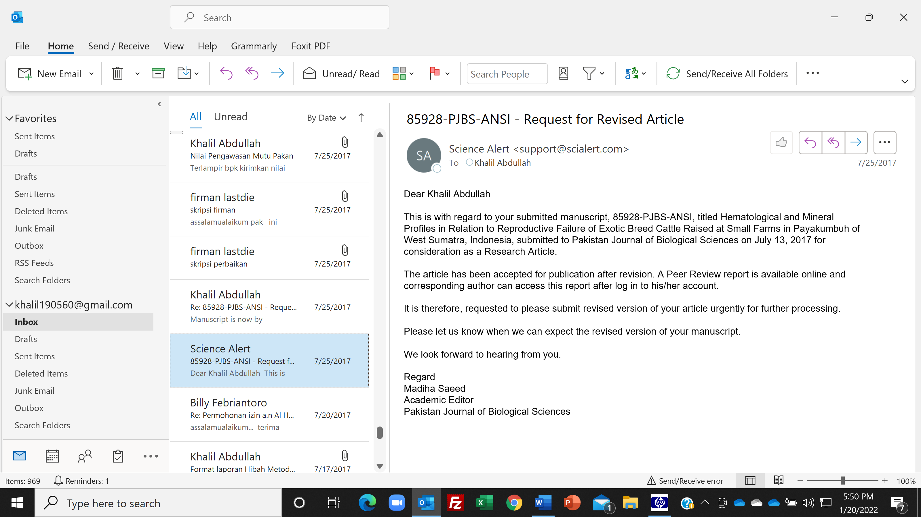
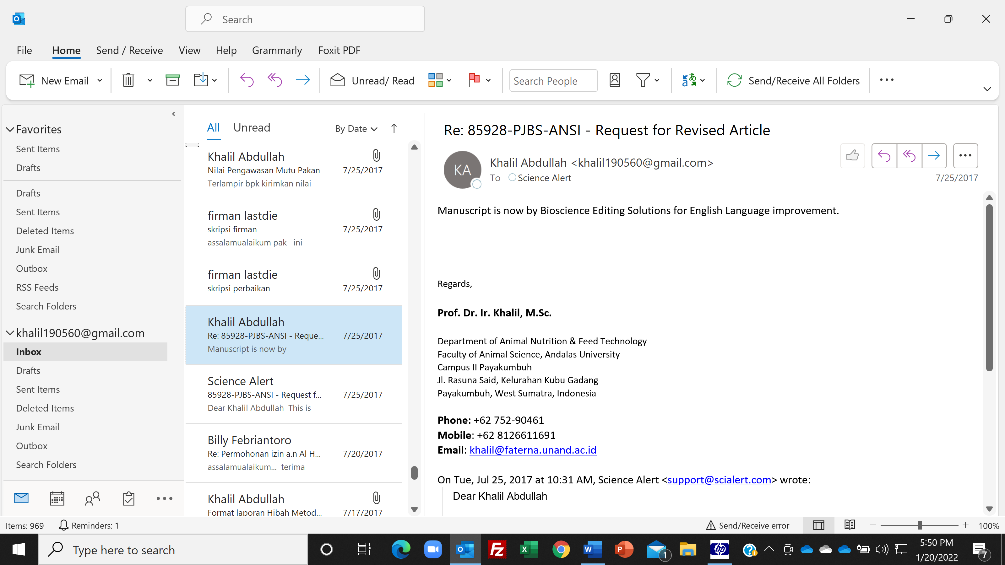

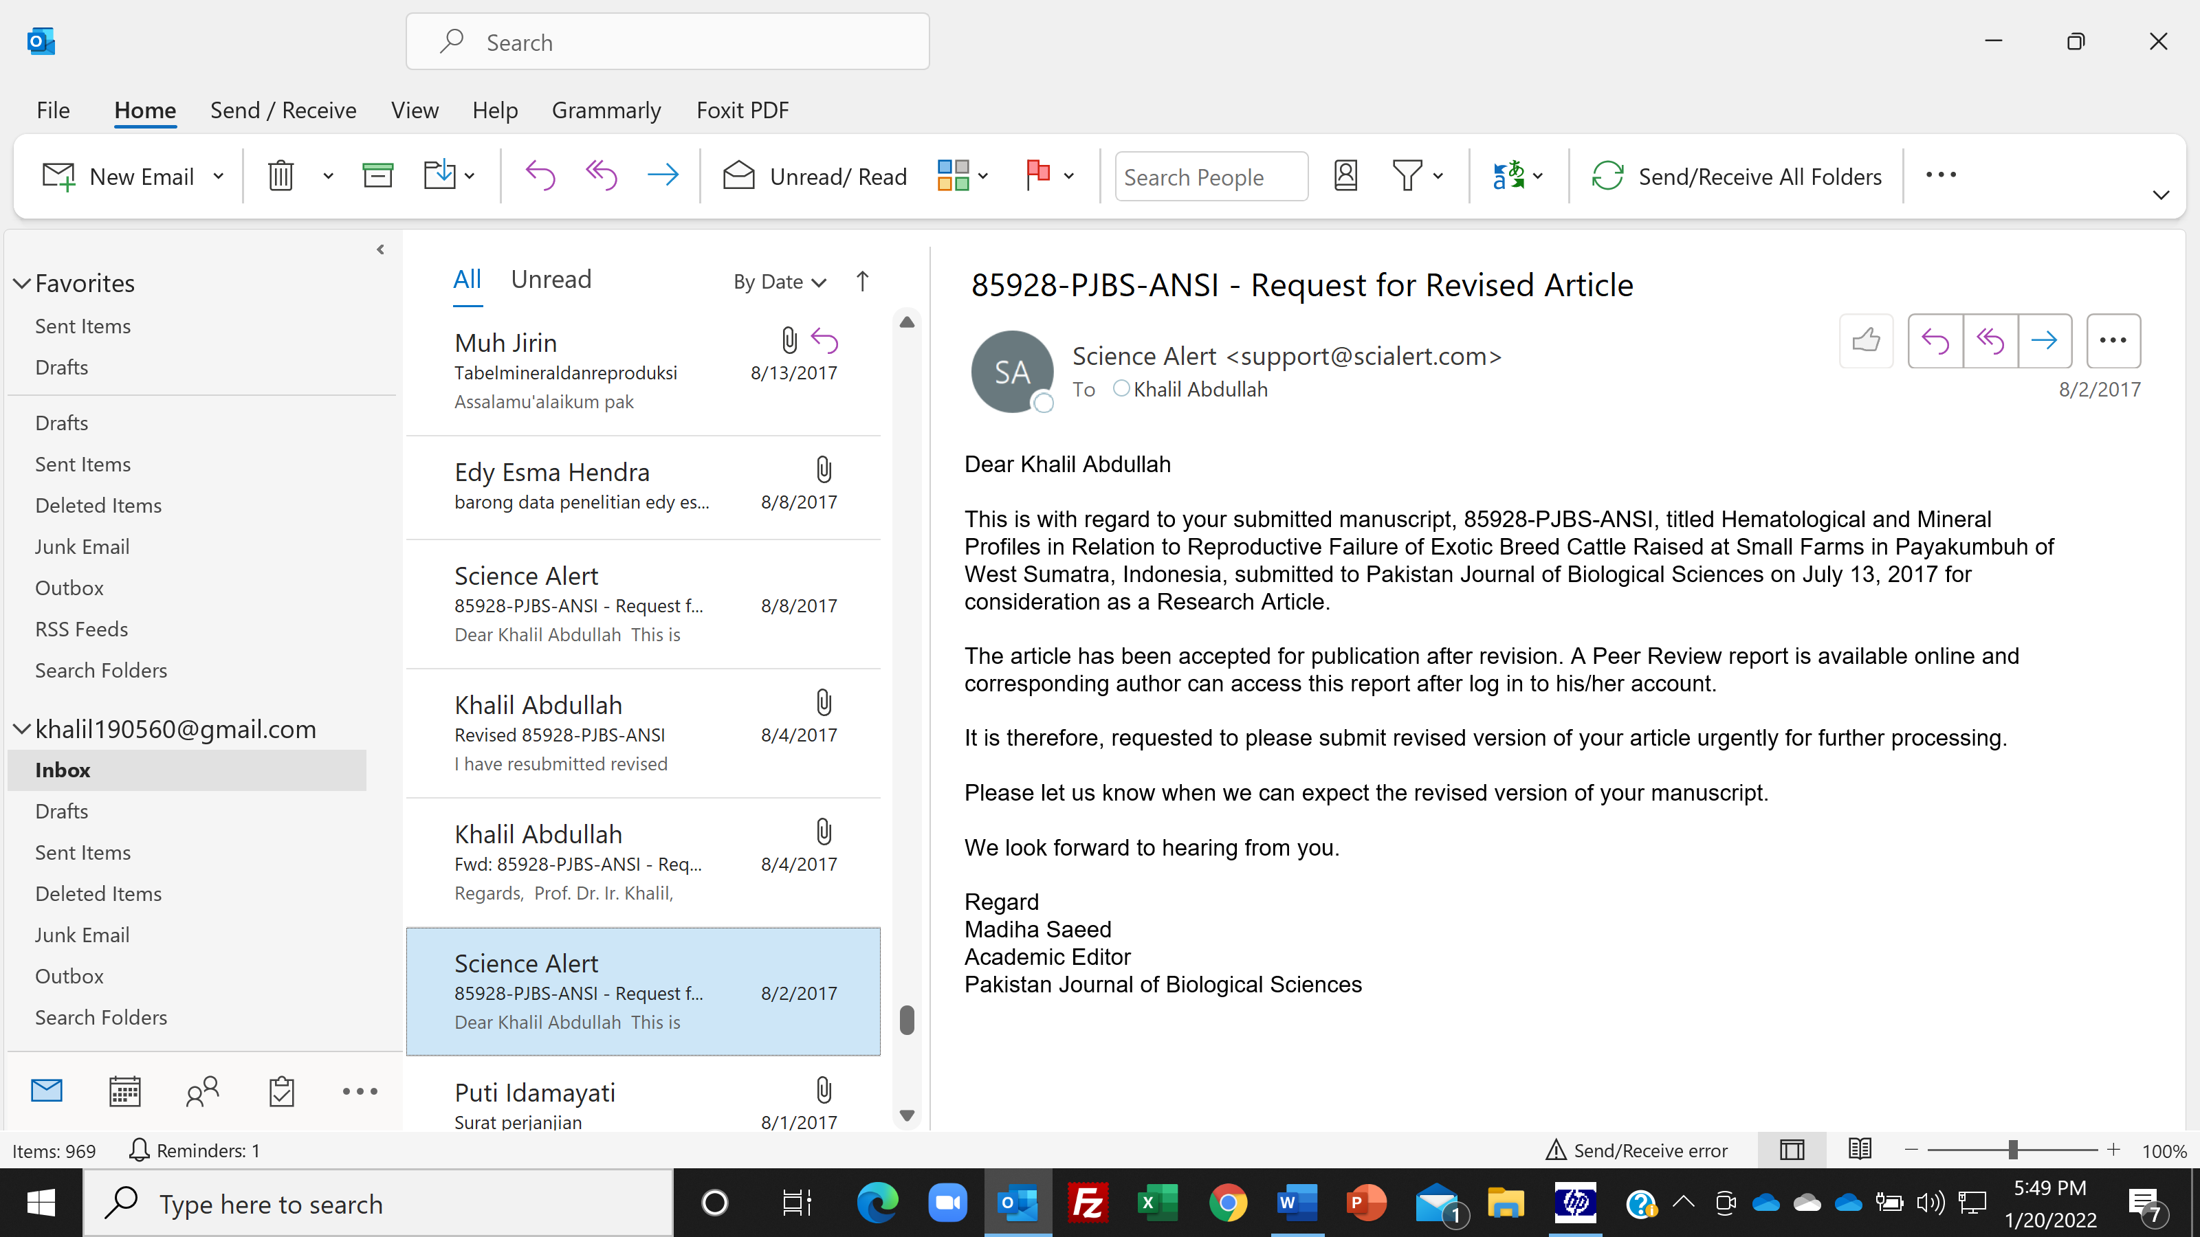

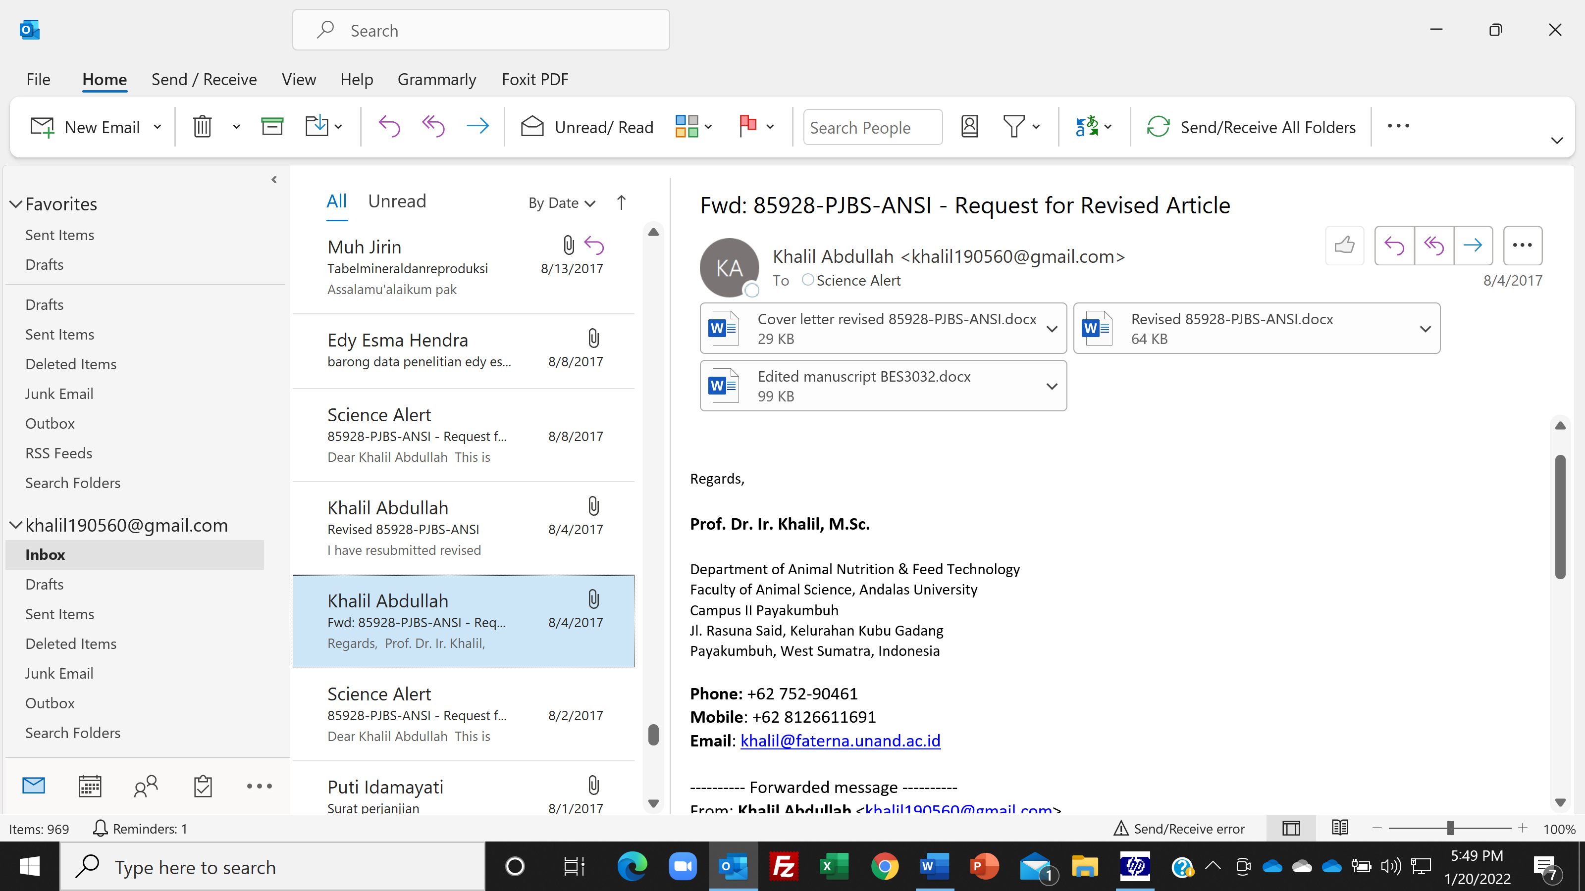

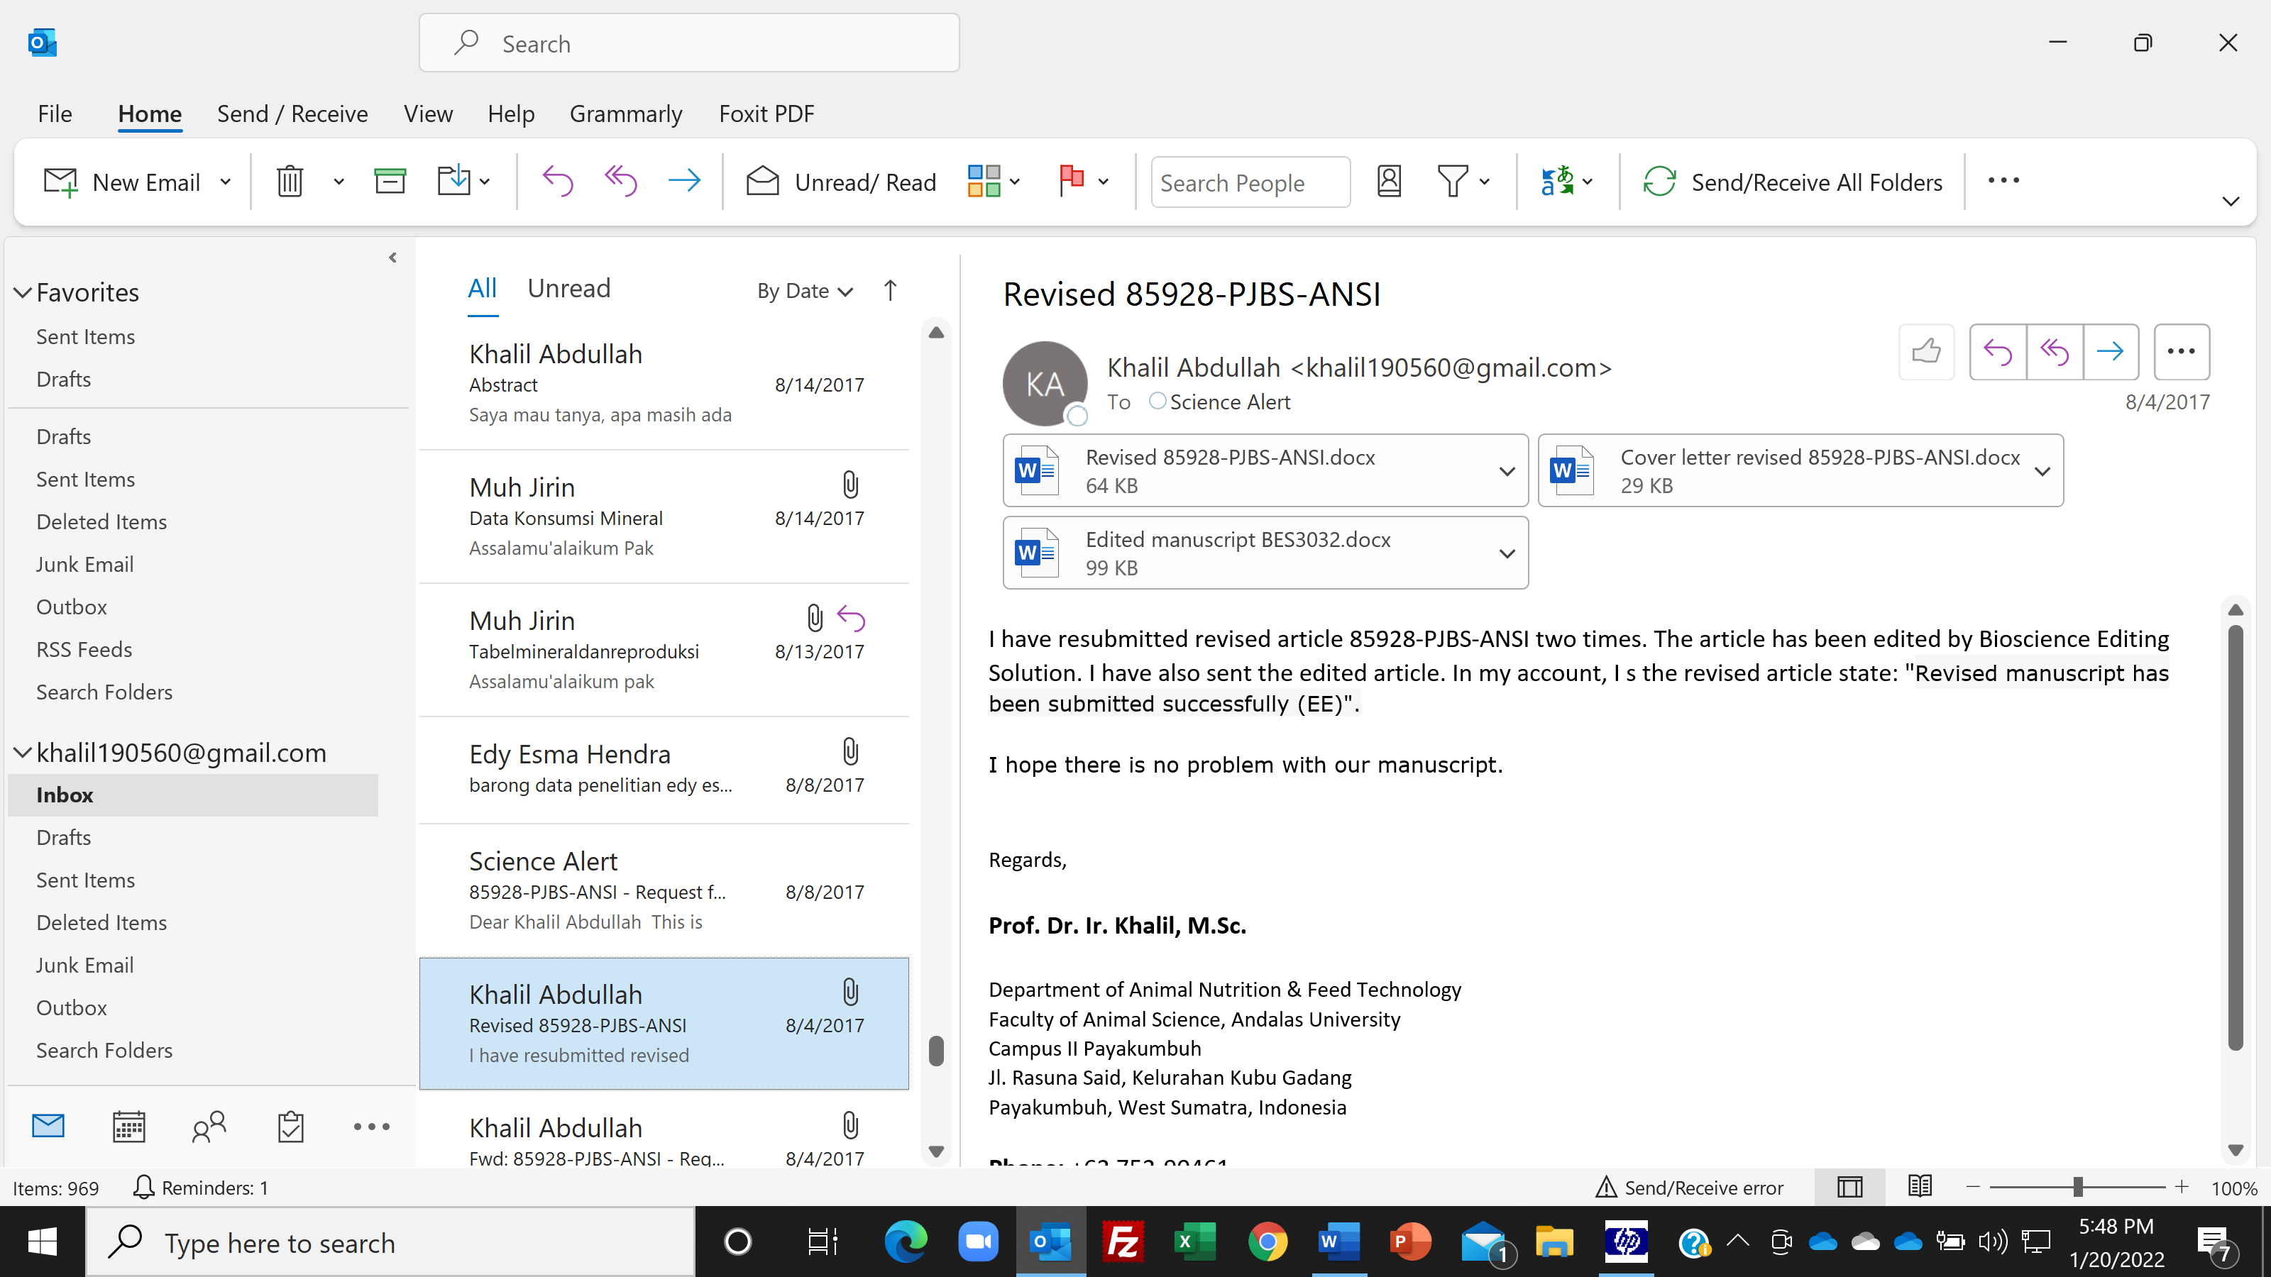

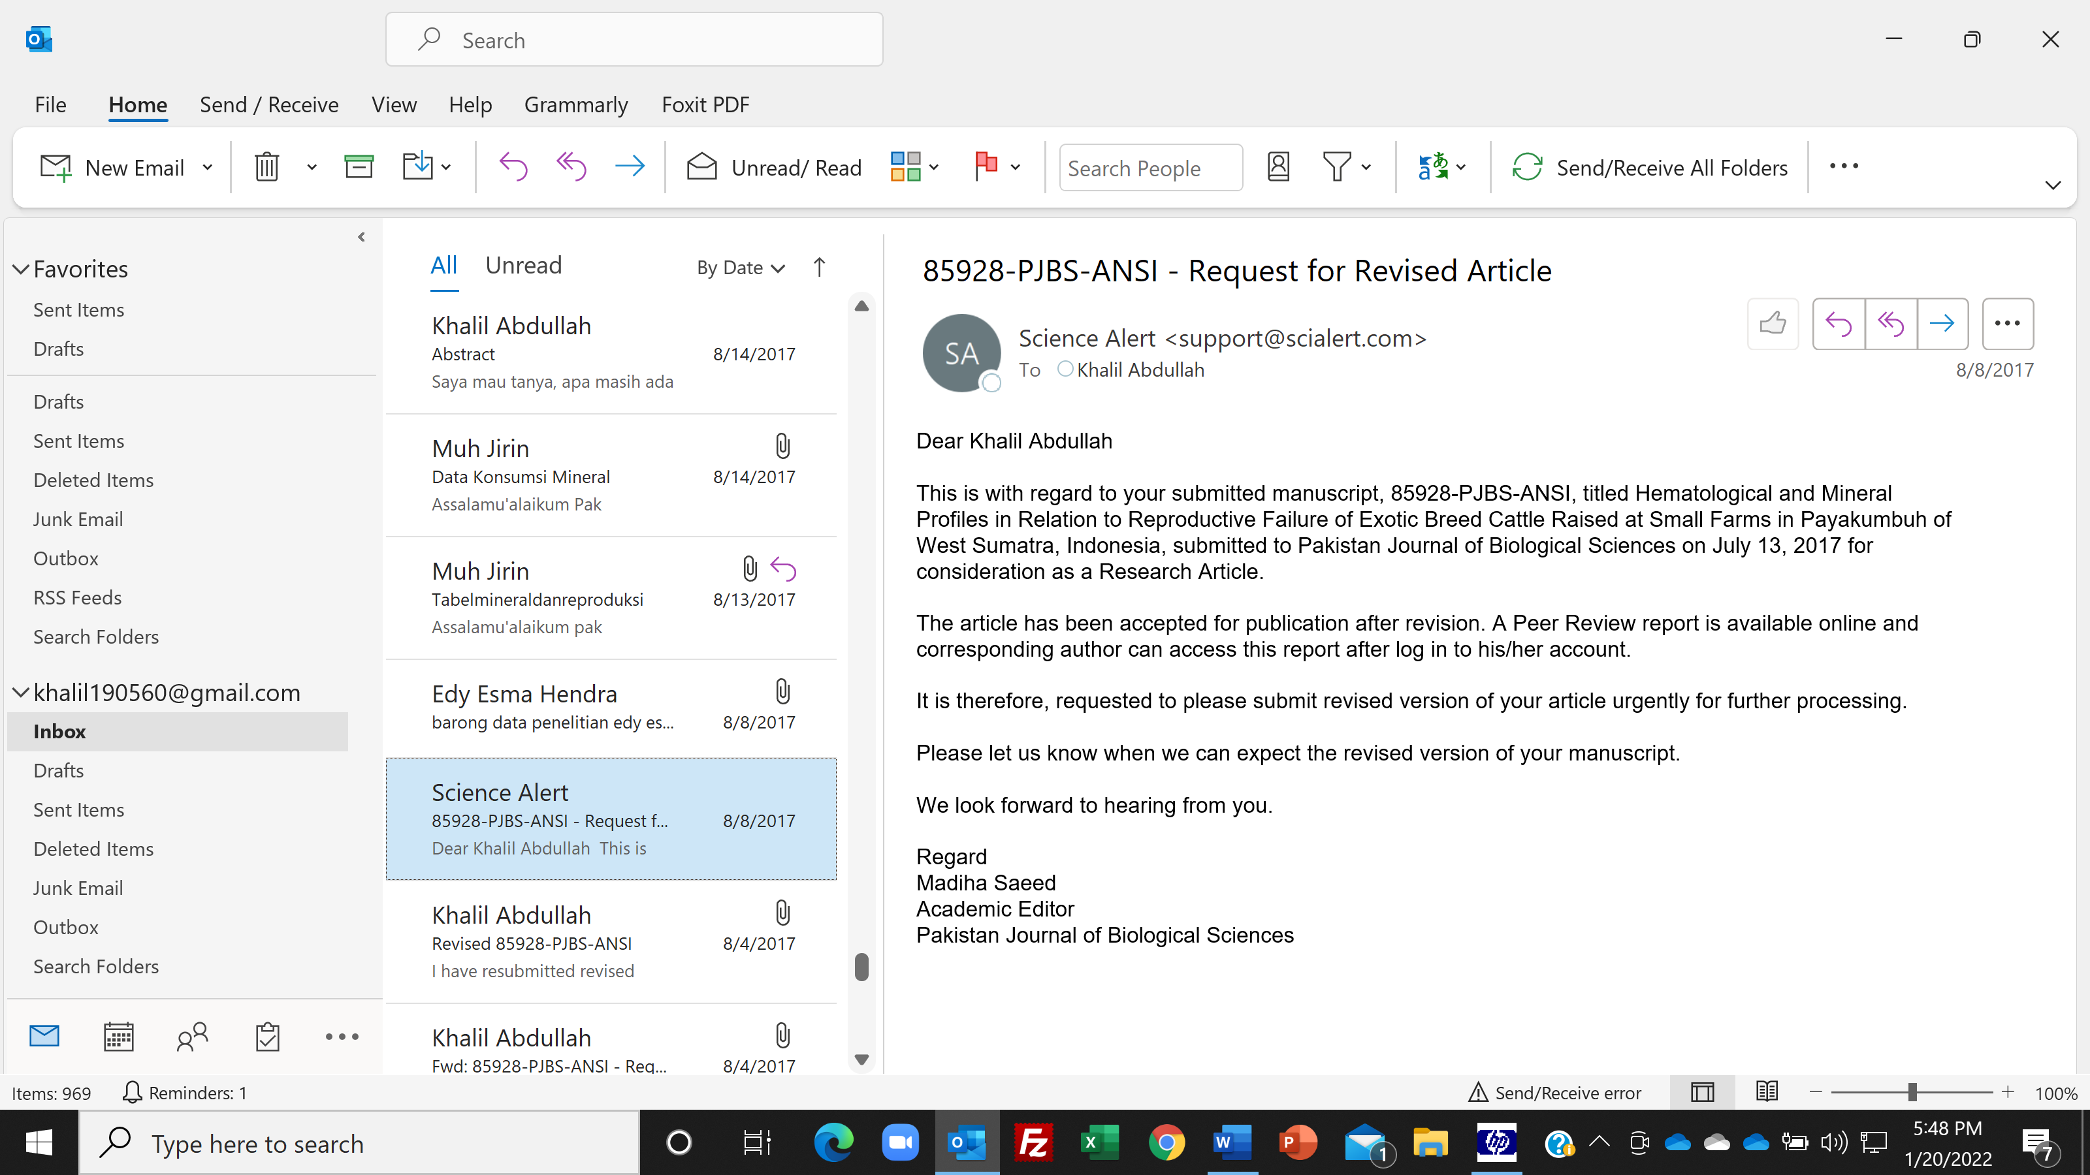

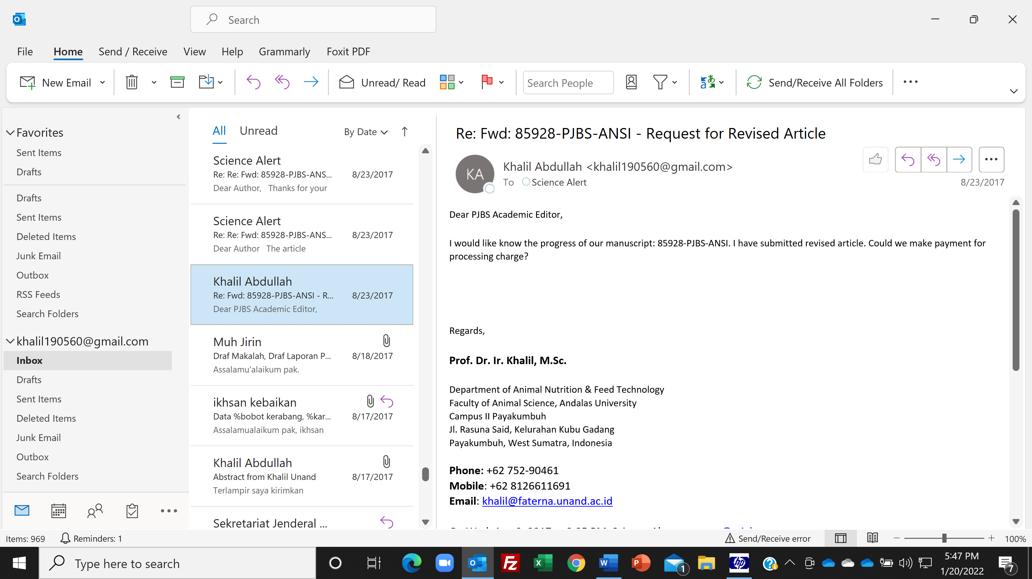

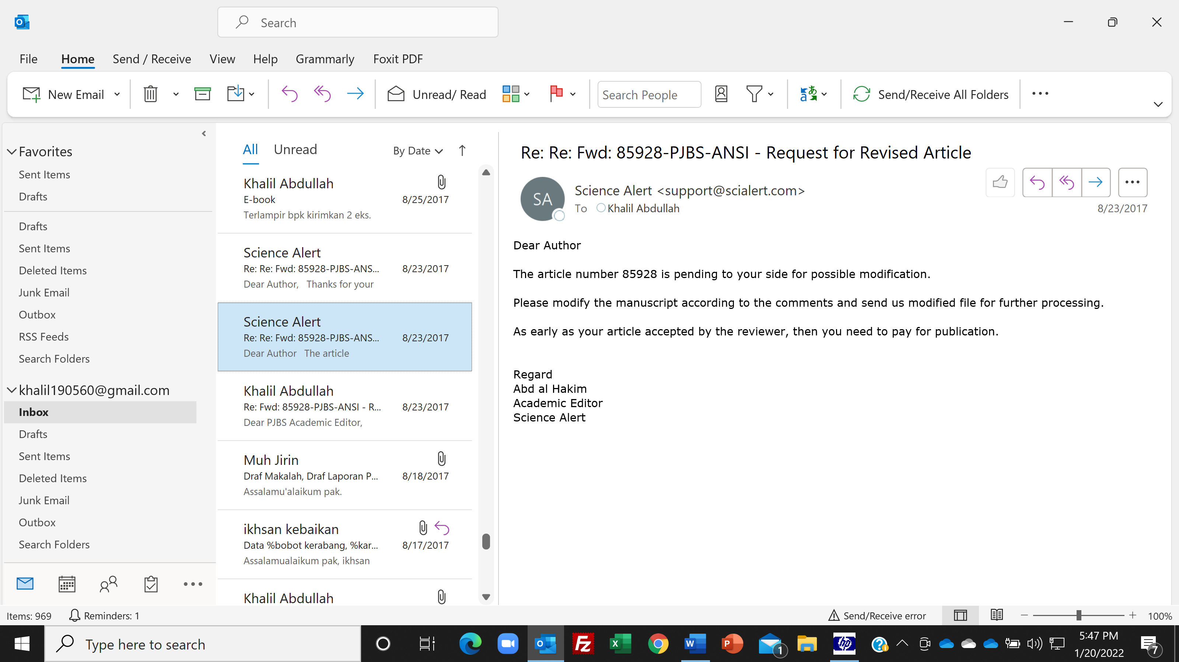

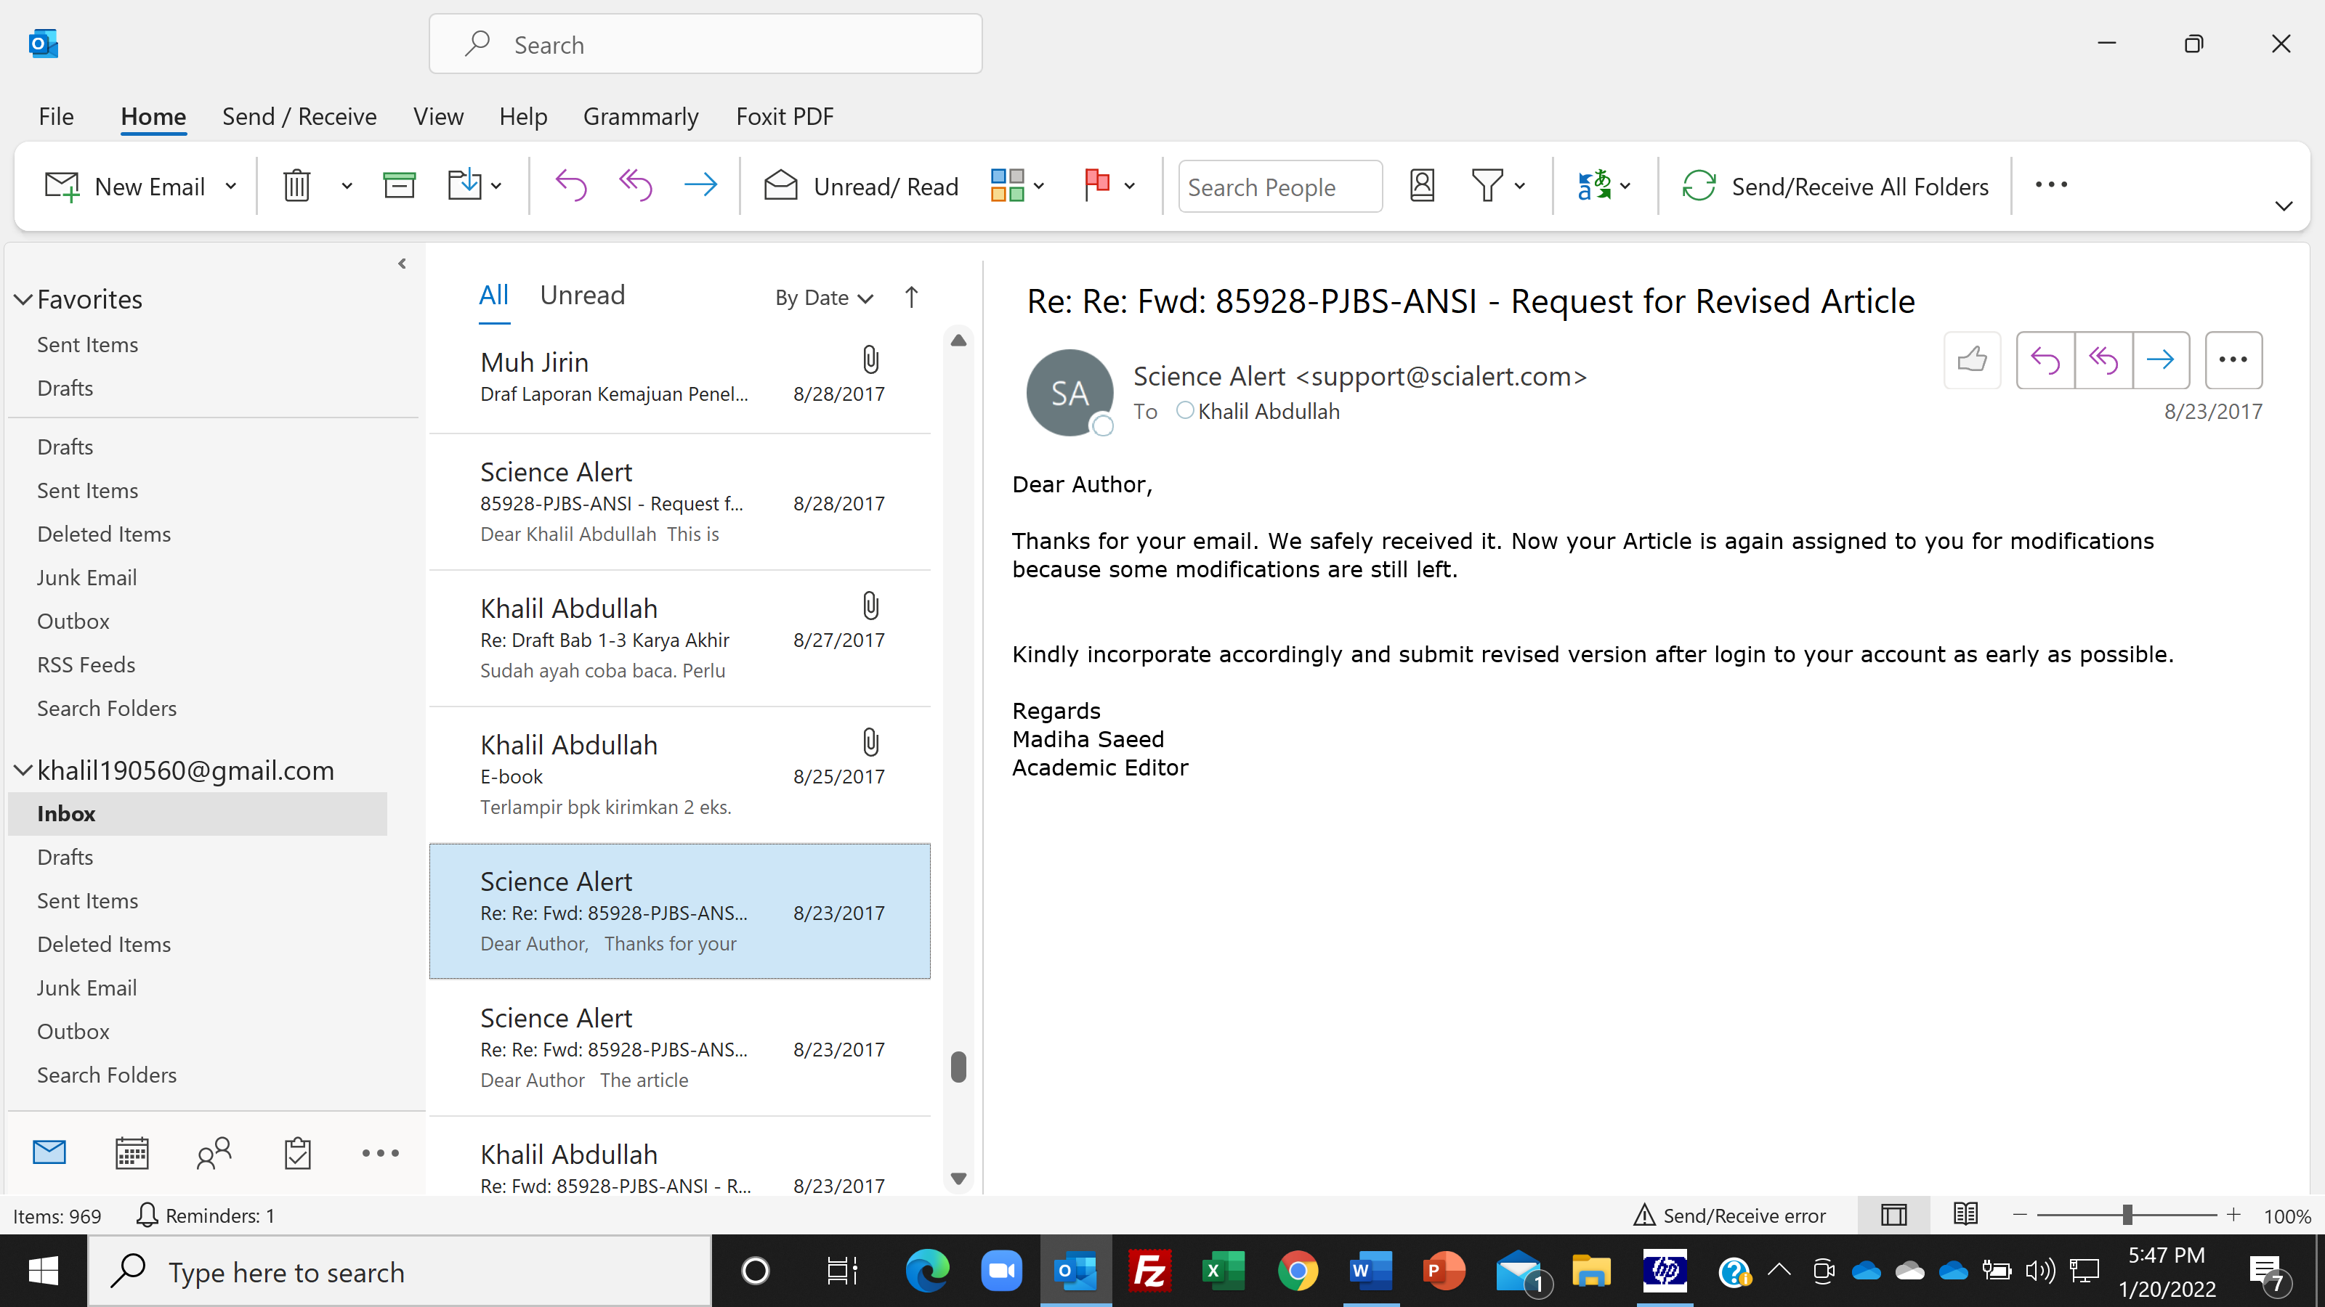

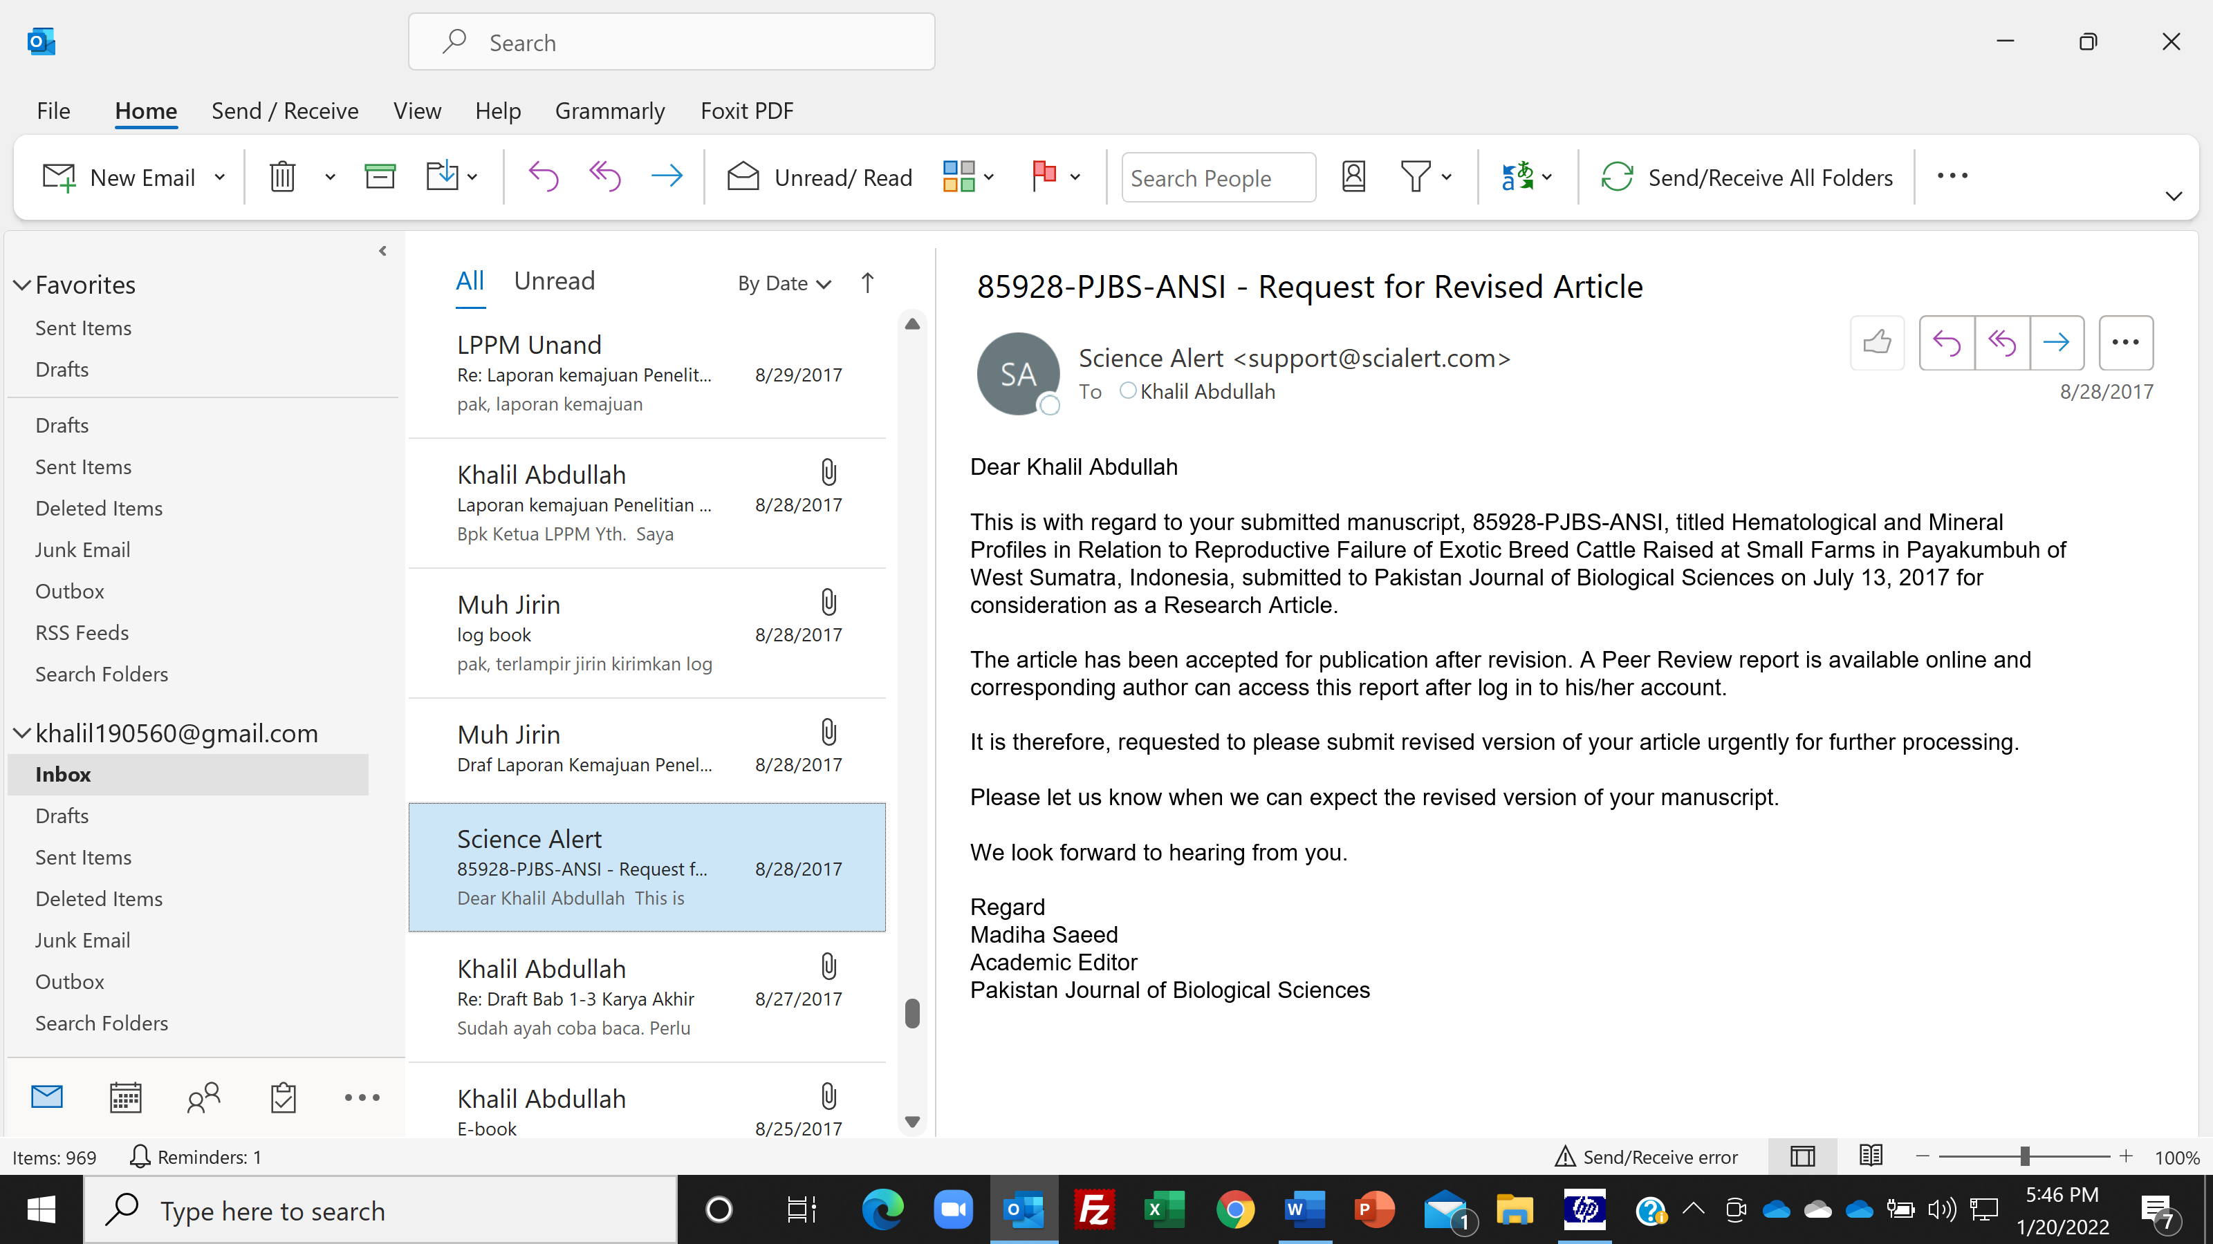

Dear PJBS Editor,

Enclosed we send transaction confirmation for payment of processing charge
of manuscript:85928-PJBS-ANSI.
Please check and send us payment receipt.

Transaction confirmation | |

|
| Science Alert |
| Transaction reference: | 030009618203 |
| Transaction type: | Sale |
| Amount: | $625.00 |
| Description: | Publication / Processing Charges |
| Time: | 3:22 AM on Sunday the 10th of September, 2017 |
| Authorisation Code: | 147476 |
| Card: | Visa Credit ending 4331 |

Regards,

Prof. Dr. Ir. Khalil, M.Sc.

Department of Animal Nutrition & Feed Technology
Faculty of Animal Science, Andalas University
Campus II Payakumbuh
Jl. Rasuna Said, Kelurahan Kubu Gadang
Payakumbuh, West Sumatra, Indonesia

Phone: +62 752-90461
Mobile: +62 8126611691
Email: khalil@faterna.unand.ac.id

On Sun, Sep 10, 2017 at 7:15 AM, Khalil Abdullah <khalil190560@gmail.com> wrote:
Dear Editor of PJBS,

We have completed payment for our invoice number of 859281NV17 this morning
via credit card with transaction reference: 0300009618203. However the
payment status in my account is still PENDING. Please check it, I hope that there is no problem with the payment.

Regards,

Prof. Dr. Ir. Khalil, M.Sc.

Department of Animal Nutrition & Feed Technology
Faculty of Animal Science, Andalas University
Campus II Payakumbuh
Jl. Rasuna Said, Kelurahan Kubu Gadang
Payakumbuh, West Sumatra, Indonesia

Phone: +62 752-90461
Mobile: +62 8126611691
Email: khalil@faterna.unand.ac.id

On Sat, Sep 9, 2017 at 5:19 PM, Science Alert <support@scialert.com> wrote:
Dear Khalil Abdullah

This is with regard to your submitted manuscript, 85928-PJBS-ANSI, titled Hematological and Mineral Profiles in Relation to Reproductive Failure of Exotic Breed Cattle Raised at Small Farms in Payakumbuh of West Sumatra, Indonesia, submitted to Pakistan Journal of Biological Sciences on July 13, 2017 for consideration as a Research Article.

The above mentioned manuscript has been finally accepted by the Reviewer for publication in Pakistan Journal of Biological Sciences as Research Article. Corresponding author may download the final acceptance letter after log in to his/her account.

Before we can continue with final production, it is mandatory to pay Article Processing Charges. All articles published in our journals are open access and freely available online, immediately upon publication. This is made possible by an article-processing charge (APC) that covers the range of publishing services we provide. This includes provision of online tools for editors and authors, article production and hosting, liaison with abstracting and indexing services, and customer services. The APC, payable when your manuscript is editorially accepted and before publication, is charged to either you, or your funder, institution or employer.

Corresponding Author may download the invoice after log in to his/her account.

Therefore, It is requested to please pay the Article Processing Charges urgently so that we may send your article to the Production Department for final publication.

We look forward to hearing from you.

Regard
Madiha Saeed
Academic Editor
Pakistan Journal of Biological Sciences

Dear PJBS Academic Editor,

Enclosed we submit revised manuscript 85928-PJBS-ANSI. We also submit list of revised items in cover letter.

Regards,

Prof. Dr. Ir. Khalil, M.Sc.

Department of Animal Nutrition & Feed Technology
Faculty of Animal Science, Andalas University
Campus II Payakumbuh
Jl. Rasuna Said, Kelurahan Kubu Gadang
Payakumbuh, West Sumatra, Indonesia

Phone: +62 752-90461
Mobile: +62 8126611691
Email: khalil@faterna.unand.ac.id

On Thu, Aug 31, 2017 at 1:35 PM, Science Alert <support@scialert.com> wrote:

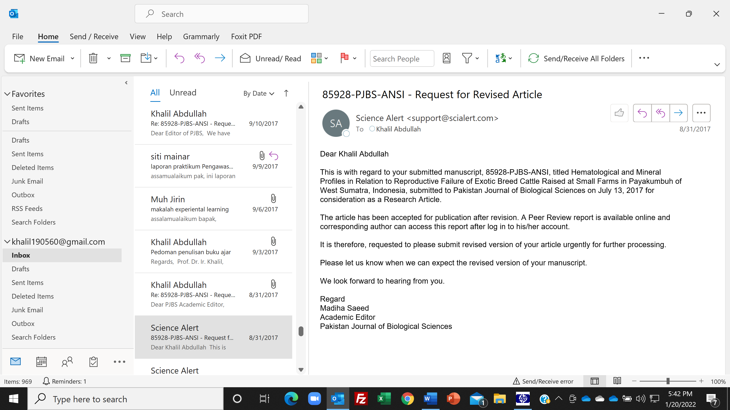

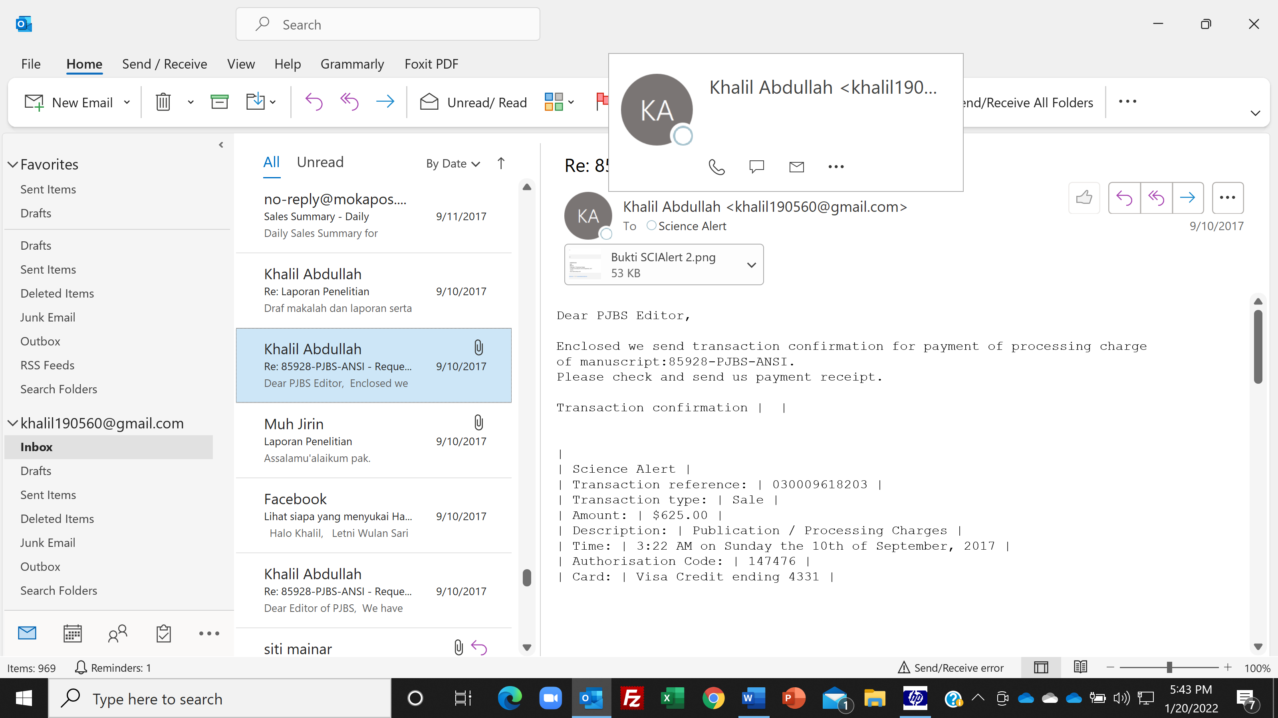

Dear PJBS Academic Editor,

Enclosed we submit revised manuscript 85928-PJBS-ANSI. We also submit list of revised items in cover letter.

Regards,

Prof. Dr. Ir. Khalil, M.Sc.

Department of Animal Nutrition & Feed Technology
Faculty of Animal Science, Andalas University
Campus II Payakumbuh
Jl. Rasuna Said, Kelurahan Kubu Gadang
Payakumbuh, West Sumatra, Indonesia

Phone: +62 752-90461
Mobile: +62 8126611691
Email: khalil@faterna.unand.ac.id

On Thu, Aug 31, 2017 at 1:35 PM, Science Alert <support@scialert.com> wrote:
Dear Khalil Abdullah

This is with regard to your submitted manuscript, 85928-PJBS-ANSI, titled Hematological and Mineral Profiles in Relation to Reproductive Failure of Exotic Breed Cattle Raised at Small Farms in Payakumbuh of West Sumatra, Indonesia, submitted to Pakistan Journal of Biological Sciences on July 13, 2017 for consideration as a Research Article.

The article has been accepted for publication after revision. A Peer Review report is available online and corresponding author can access this report after log in to his/her account.

It is therefore, requested to please submit revised version of your article urgently for further processing.

Please let us know when we can expect the revised version of your manuscript.

We look forward to hearing from you.

Regard
Madiha Saeed
Academic Editor
Pakistan Journal of Biological Sciences

