A Title Should be the Fewest Possible Words That Accurately Describe the Content of The Paper, Capitalize Each Words but Conjunction (and, or, with, etc.)   
(Style Template MS Word: 1. Tittle)

First Author1, Second Author1, Second Author2

1 The address or affiliation of each is written in full

2 Department of Physics, Universitas Andalas, Padang, Indonesia

|  |  |  |
| --- | --- | --- |
| Article Info |  | ABSTRAct (style MS Word: *51.ABSTRACT TITTLE*) |
| Article History:  Received mm dd, yyyy  Revised mm dd, yyyy  Accepted mm dd, yyyy |  | A well-prepared abstract enables the reader to identify the basic content of a document quickly and accurately, to determine its relevance to their interests, and thus to decide whether to read the document in its entirety. The Abstract should be informative and completely self-explanatory, provide a clear statement of the problem, the proposed approach or solution, and point out major findings and conclusions. The Abstract should be 100 to 200 words in length. The abstract should be written in the past tense. Standard nomenclature should be used and abbreviations should be avoided. No literature should be cited. The keyword list provides the opportunity to add keywords, used by the indexing and abstracting services, in addition to those already present in the title. Judicious use of keywords may increase the ease with which interested parties can locate our article. (Using style MS Word: 53. Isi Abstract).  *Copyright © 2022 Author(s)* |
| Keywords:  *first keyword*  *second keyword*  *third keyword*  *fourth keyword*  *fifth keyword* |
| Corresponding Author:  Name of Corresponding Author,  Email: [name@sci.unand.ac.id](mailto:name@sci.unand.ac.id) |

# introduction (style template *heading 1*)

The introduction contains the background, previous studies related to the research, objectives, and the basic theory regarding this manuscript. Before starting typing, to avoid formatting errors, authors are expected to download the writing template and guide for authors at <http://jif.fmipa.unand.ac.id/> . Use the MS Word: 63 Body style for this section. The style display in MS Word can be opened on the Home menu at the top right, you can see an arrow as shown in Figure 1. Click the down arrow so that it will appear on the right side of the screen (Figure 2) to make it easier to type the script.

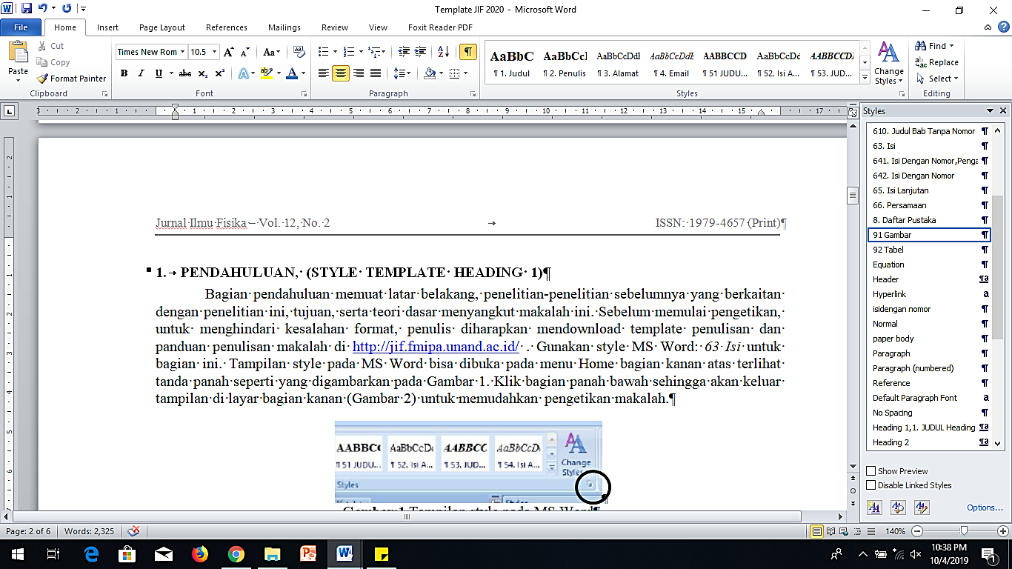

**Figure 1.** Style display in MS Word (Use MS Word Style Template: 91 Figure).

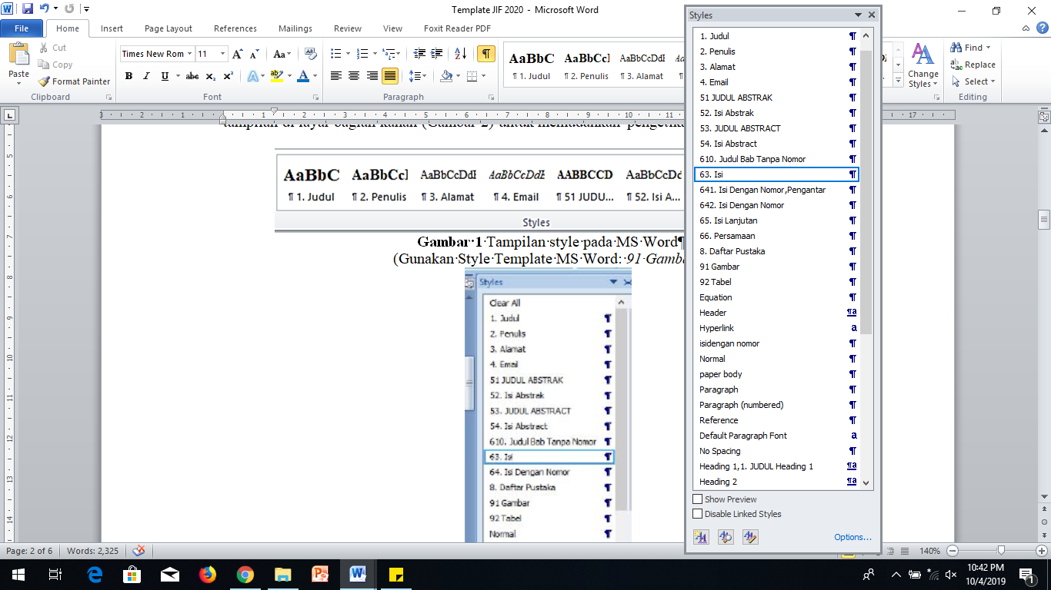

**Figure 2.** The display of template style after the arrow in Figure 1 is clicked.

Please ensure that every reference cited in the text is also present in the reference list (and vice versa). Any references cited in the abstract must be given in full. Unpublished results and personal communications are not recommended in the reference list, but may be mentioned in the text. If these references are included in the reference list they should follow the standard reference style of the journal and should include a substitution of the publication date with either 'Unpublished results' or 'Personal communication'. Citation of a reference as 'in press' implies that the item has been accepted for publication. **JIF requires that all references and citations use reference management software such as Mendeley. Please select APA style.**

# method (style template heading 1)

This section describes the research methods. The method can be explained through the steps taken and assisted by using a flow chart or tables.

Each paragraph must contain a specific main idea. One paragraph consists of several sentences that link between sentences. Thus, one paragraph can not be one sentence.

Chapters can be divided into sub-chapters and sub-sub-chapters. For sub-chapter template styles, use **Heading 2**, while for sub-chapters, use **Heading 3**. It is not allowed to change the style of the template manually.

## Equation (Style Template Heading 2)

### Writing Equations (Style Template Heading 3)

Write the Equation using Microsoft Word's Equation Editor (Microsoft Equation 3.0 or later). To write the Equation, the author can copy-paste Equation (1) (recommended). If the Equation is not written using Microsoft Equation, the manuscript will be returned, and the author needs to make revisions. The Equation is placed in the middle position with the equation number at the right. Use the MS Word template style *641. Fill with Numbers, Introduction, to write the Equation.*



Write the meaning of the symbol in a sentence within a paragraph. Symbols are written directly in MS Word and are italicized (don't put equation templates in the text). For example, is the density, and g is the acceleration due to gravity. If the sentence in the next line is a continuation of the previous sentence that is cut off by an equation, table, or figure, use a style template MS Word: *65 Advanced Content* . To create an equation number manually, use the following steps (use style template MS Word: *641. Fill With Number;Introduction*)

# RESULTS and discussion (style template heading 1)

## Figure (Style Template Heading 2)

The figure must provide information and support the idea described in the text. All figures must be cited in the text as “Figure x” along with information explaining the meaning of the figure. The figure is placed as close as possible to the sentence that refers to the figure.

### Figure Format

The image is in “image” or pdf format and is placed in the middle position. The image must be layout in line with the text—Right-click on the image and select “Wrap Text” (Figure 3). Then, select the menu wrapping style "In line with text".

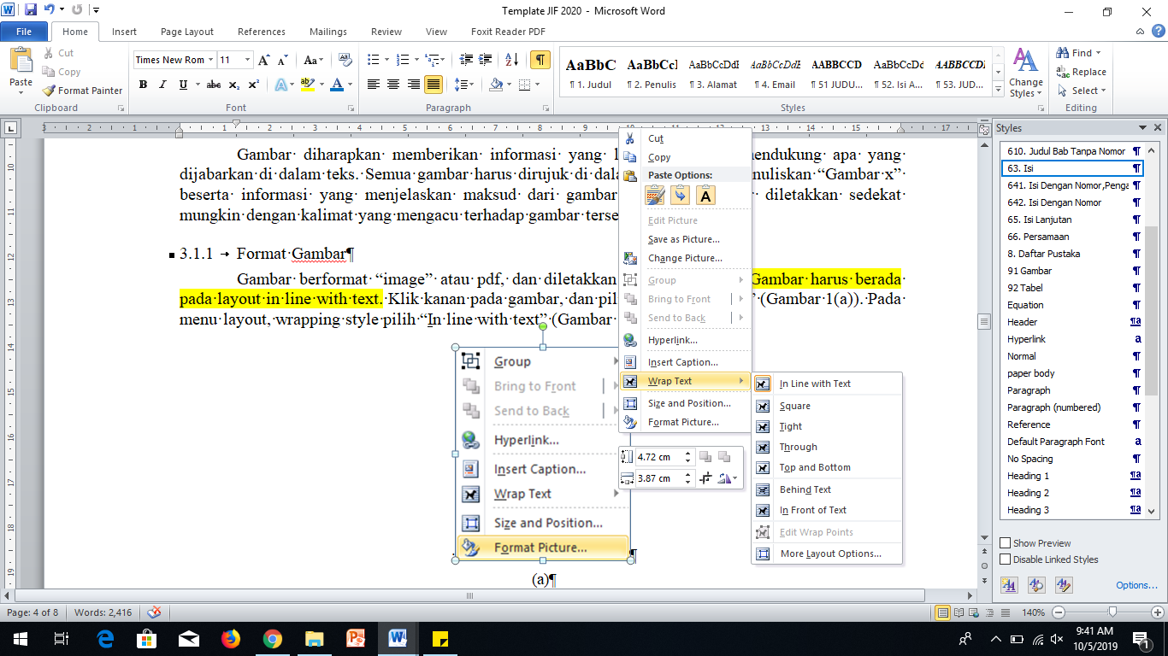

**Figure 3** Figure must be in “*In line with text”* (use style template MS Word: *91. Figure*)

### Figure Quality

Authors must check all figures both on-screen (zoom in) and the results on the print version. When checking the printed version of the figure, make sure that; (1) colors have sufficient contrast, (2) images are pretty clear, and (3) all labels on images are readable. If the information in the image is not readable, the manuscript will be returned to the author.

Figure 4(a) shows an example of an image with a low resolution that does not meet the requirements, while Figure 4(b) shows an example of an image with adequate resolution. Check that the image resolution is sufficient to reveal essential details in the figure. For the print version, vector format is preferred. In the case of photos, etc., a resolution of 300 dpi should be provided. Please ensure that all text in images is readable - the smallest allowed font size is 8pt.



(a)

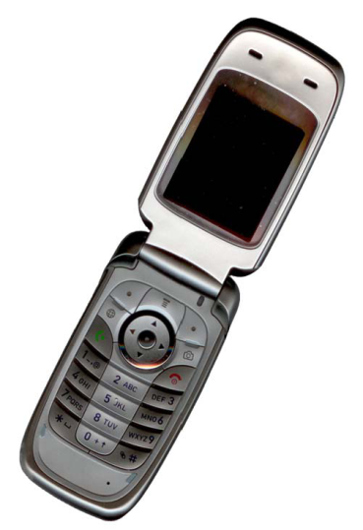

(b)

**Figure 4** (a) An example of an image with poor resolution and (b) an example of an image with good resolution (use style template MS Word: *91. Figure*)

Figure numbering starts from 1, 2, etc., and is written in bold, for example: “**Figure 4**”. If the figure consists of more than one, then use labels (a), (b) etc., using Times New Roman font size 10. If the figure is made into two columns, then use the example in Figure 4. Figure label description and captions are not arranged in a table. Figure captions and figures must be on the same page.

## Table (Style Template Heading 2)

The contents of the table are written in the format as in Table 1. Column headings are written in bold using Times New Roman font size 10, and table contents using Times New Roman font size 10. Commas in Indonesian are written in (,), not (.). All table data are on the same page

**Table 1** Writing style for table (use style template MS Word: *92.Tabel*)

|  |  |  |  |
| --- | --- | --- | --- |
| **Column Title** | **Column Title** | **Column Title** | **Column Title** |
| Line tittle | X | X | X |
| line tittle | X | X | X |
| line tittle | X | X | X |

# conclusion (style template heading 1)

The conclusion states the study's final results, and it is written in paragraphs, not in numerical order.

acknowledgement, (style template *610. acknowledgement*)

This section does not have to exist. This section generally contains institutions or people who help carry out the research or sponsors who provide financial support.

Reference, (style template *610. acknowledgement*)

The primary references are international journals and proceedings. All references must come from the most relevant and newest sources indicated by 50% of the references used must be published in the last ten years. The minimum number of references is 15, and at least 80% of the references are scientific journals and proceedings. **JIF requires that all references and citations use reference management software such as Mendeley. Please select APA style.**  see examples below:

**Book**

***Single author***

Baxter, C. (1997). *Race equality in health care and education*. Philadelphia: Balliere Tindall.

***Two author***

Cone, J.D., & Foster, S.L. (1993). *Dissertations and theses from start to finish: Psychology and related fields*. Washington, DC: American Psychological Association.

***Without author***

*Merriam-Webster’s collegiate dictionary* (10th ed.). (1993). Springfield, MA: Merriam-Webster.

***Not the first edition***

Mitchell, T.R., & Larson, J.R. (1987). *People in organizations: An introductions to organizational behavior* (3rd ed.). New York: McGraw-Hill.

***The author is a team or institution***

American Psychiatric Association. (1994). *Diagnostic and statistical manual of mental disorders* (4th ed.). Washington, DC: Author.

***Series/multi-volume books (editor as author)***

Koch, S. (Ed.). (1959-1963). *Psychology: A study of science* (Vols. 1-6). New York: McGraw-Hill.

***Translation***

Kotler, Philip. (1997). *Manajemen pemasaran: Analisis, perencanaan, implementasi* (Hendra Teguh & Ronny Antonius Rusli, Penerjemah.). Jakarta: Prenhallindo.

***Article or chapter in an edited book***

Eiser, S., Redpath, A., & Rogers, N. (1987). Outcomes of early parenting: Knowns and unknowns. In A. P. Kern & L. S. Maze (Ed.). *Logical thinking in children* (pp. 58-87). New York: Springer.

***Articles/terms in reference books***

Schneider, I. (1989). Bandicoots. In *Grzimek’s encyclopedia of mammals* (vol.1, pp. 300 304). New York: McGraw-Hill.

***Manuscripts of seminars, conferences, and etc.***

***(before publication)***

Crespo, C.J. (1998, March). *Update on national data on asthma.* Paper presented at the meeting of the National Asthma Education and Prevention Program, Leesburg, VA.

***(printed-published)***

Williams, J., & Seary, K. (2010). Bridging the divide: Scaffolding the learning experiences of the mature age student. In J. Terrell (Ed.), *Making the links: Learning, teaching and high quality student outcomes*. Proceedings of the 9th Conference of the New Zealand Association of Bridging Educators (pp. 104-116). Wellington, New Zealand.

***(Published online)***

Cannan, J. (2008). Using practice based learning at a dual-sector tertiary institution: A discussion of current practice. In R. K. Coll, & K. Hoskyn (Eds.), *Working together: Putting the cooperative into cooperative education*. Conference proceedings of the New Zealand Association for Cooperative Education, New Plymouth, New Zealand. Retrieved from http://www.nzace.ac.nz/conferences/papers/Proceedings_2008  
.pdf

MacColl, F., Ker, I., Huband, A., Veith, G., & Taylor, J. (2009, November 12-13). *Minimising pedestriancyclist conflict on paths*. Paper presented at the Seventh New Zealand Cycling Conference, New Plymouth, New Zealand. Retrieved from http://cyclingconf.org.nz/system/files/NZCyclingConf09_2A_MacColl_  
PedCycleConflicts.pdf

***Bachelor Thesis, Thesis, Dissertation***

***(printed)***

Johnson, S. (2013). *Style strategies* (Master’s thesis). Universal College of Learning, Whanganui School of Design, Whanganui, New Zealand.

***(online)***

Mann, D. L. (2010). *Vision and expertise for interceptive actions in sport* (Doctoral dissertation, The University of New South Wales, Sydney, Australia). Retrieved from http://handle.unsw.edu.au/1959.4/44704

**Serial**

***Journal Articles***

Clark, L.A., Kochanska, G., & Ready, R. (2000). Mothers’ personality and its interaction with child temperament as predictors of parenting behavior. *Journal of Personality and Social Psychology*, 79, 274-285.

***Magazine Articles***

Greenberg, G. (2001, August 13). As good as dead: Is there really such a thing as brain death? *New Yorker*, 36-41.

***Newspaper articles***

Crossette, Barbara. (1990, January 23). India lodges first charges in arms Scandal. *New York Times*, A4.

***Newspaper article, no author***

Understanding early years as a prerequisite to development. (1986, May 4). *The Wall Street Journal,* p. 8.

***Book reviews in journals***

Grabill, C. M., & Kaslow, N. J. (1999). Anounce of prevention: Improving children's mental health for the 21st century [Review of the book *Handbook of prevention and treatment with children and adolescents]. Journal of Clinical Child Psychology*, 28, 115 116.

***Film reviews in journals***

Lane, A. (2000, December 11). Come fly with me [Review of the motion picture *Crouching tiger, hidden dragon*]. *The New Yorker*, 129-131

***Interview***

White, Donna. (1992, December 25). Personal interview.

**Other Works and Non-Print Works**

***Television show***

Crystal, L. (Executive Producer). (1993, October 11). *The MacNeil/Lehrer news hour.* [Television broadcast]. New York and Washington, DC: Public Broadcasting Service.

***Video/VCD***

National Geographic Society (Producer). (1987). *In the shadow of Vesuvius.* [Videotape]. Washington, DC: National Geographic Society.

***CD Audio***

McFerrin, Bobby (Vocalist). (1990). *Medicine music* [Audio Recording]. Hollywood, CA: EMI-USA.

***Software***

Arend, Dominic N. (1993). *Choices (*Version 4.0) [Computer software]. Champaign, IL: U.S. Army Corps of Engineers Research Laboratory. (CERL Report No.CH7-22510)

**Electronic Publication**

***Complete work***

McNeese, M.N. (2001). *Using technology in educational settings.* October 13, 2001. University of Southern Mississippi, Educational Leadership and Research. http://www.dept.usm.edu/~eda/

***Institutional documents***

NAACP (1999, February 25). *NAACP calls for Presidential order to halt police brutality crisis.* June 3, 2001. http://www.naacp.org/president/releases/police_brutality.htm

***Institutional documents, without page numbers, without information on the year of publication***

Greater Hattiesburg Civic Awareness Group, Task Force on Sheltered Programs. (n.d.). *Fund-raising efforts.* November 10, 2001. http://www.hattiesburgcag.org

***Author and publication time information unknown***

*GVU's 8th WWW user survey.* (n.d.). September 13, 2001. http://www.gvu.gatech.edu/user_surveys/survey-1997-10/

***CD-ROM***

Ziegler, H. (1992). Aldehyde. *The Software Toolworks multimedia encyclopedia* (CDROM version 1.5). Boston: Grolier. Januari 19, 1999. Software Toolworks.