**Applications Of Indigenous Rhizobakteria And Endofit Bacteria**

**From Peat Soil In West Pasaman Regency To Increase Growth Of Palm Oil Seeds (*Elais guineensis* Jacq.) In Pre-Nursery**

**Reni Mayerni(1), Auzar Syarif(1), Nazres Akhir(1), Patrisno(2) dan Ismu Hadi Nurmawan(2)**

1)     Lecturer in Agrotechnology Program, Faculty of Agriculture, Andalas University Padang, West Sumatra, Indonesia

2)     Student in Agrotechnology Program, Faculty of Agriculture, Andalas University Padang, West Sumatra, Indonesia

E-mail address: renimayerni@agr.unand.ac.id

**Abstract**

This study aims to obtain the best type of indigenous rhizobacteria and endofit bacteria from peat soil isolation results for the growth of palm oil seedlings in Pre-Nursery. This research has been conducted from July to November 2017 at Microbiology and Experimental Field Laboratory, Faculty of Agriculture, Andalas University. The study used experimental method, using completely randomized design. Treatment used for the application of indigenous rhizobacteria as much as 19 isolates and 1 without isolate. As for the introduction of isolates of endofit bacteria as much as 18 isolates and 1 without isolate. Each treatment used 3 replications. The observation variables included morphology of indigenous rhizobacteria and endofit bacteria, gram test, hypersensitivity reaction test, plant height, leaf number, leaf area, diameter of stem, root length, root canopy ratio and the value of effectiveness. From the result of the research, it is known that indigenous rhizobacteria isolate of RZ2PB2.2 andendofit bacteria E1 PB2.1.1 give the best result on observed variables compared with without isolate.

Keywords : *Palm oil, indigenous* *rhizobacteria, endofit bacteria, peat soil, West Pasaman*

1. **Introduction**

Palm oil (*Elaeis guineensis* Jacq.) is one of the plantation commodities whose development is quite fast compared to other plantation commodities. It is estimated that by 2020 with a world population of about 8 billion humans needs 234 million tons of vegetable oil, meaning that it needs an additional supply of 6 million tons per year until 2020 (GAPKI, 2013).

The area of ​​oil palm plantations in Indonesia ranks first with an average contribution of 35.69% of the total area of ​​oil palm (Kementan, 2014), for the last seven years tends to increase, up about 3.27 to 11.33% per year. In 2017 it increased by 4.46% to 11.67 million ha with total production of 3 million tons (BPS, 2017). Sumatera to date has a total area of ​​7.379,993 ha of oil palm plantations and an average productivity of TBS of 2.6-4.0 tons / ha while for West Sumatra has a total area of ​​413,453 ha and an average productivity of TBS of 2.6 tons / ha, both smallholders and large plantations owned by the company (Direktorat Jenderal Perkebunan, 2017).

Land used as planting area consists of dry land and swamp land. In West Sumatra, the peatland area is about 140,000 ha spread in Pesisir Selatan, Padang Pariaman and Pasaman districts (Bappeda, 2000). In mainland Anai Padang Pariaman there are about 6,551 ha of peatland (Faperta Unand, 1986).

In the improvement and expansion of oil palm plantations need to pay attention to aspects that can increase productivity. Among them is the use of superior seeds, because the seeds used will determine the quality of the plant and the results will be obtained.

Nursery management is one of the important factors that affect the quality and quantity of garden products (Mangoensoekarjo,2007). The most widely used system in palm oil breeding today is a double stage system consisting of pre-nursery and main nursery. Pre-nurseryis a nursery activity up to 3 months old , because the early seeding is very determining the productivity of plants in the field so that the growth and yield of palm fruit bunches produced maximum (PPKS, 2008).

An alternative that can be used to improve the quality of oil palm seedlings is by using plant growth micro-organisms. Many microorganisms reported as biocontrol agents and plant growth enhancers are Rhizobacteria (Soesanto, 2008).

Rhizobacteria is a heterogeneous group of bacteria found in the rhizosphere complex (soil), on the root surface (rizoplant) and associated in the root (endophytes) (Yanti, 2013). Rhizobacteria acts as PGPR by providing certain nutrients for plants (Supramana, *et al.*, 2007), and can improve the quality of growth plant (Joseph, *et al*., 2007).

In swamp lands such as peatlands, there is an acidophilic group of microbes that play an important role in the decomposition process of various organic materials (Alexander, 1977). The result of Fajria research (2015), the growth of rubber plant shows that the introduction of some types of rhizobacter adaptation to the green eye grafting eye of rubber plant affect the shoot length and the width of the leaf canopy and the result of Pradana, *et al.* (2015) endophytic bacteria isolated from plant roots adam and hawa (*Rheo spathaceae*) showed that endophytic bacteria isolate increased rice seed growth higher than control.

Based on the above description, rhizobacteria and endophytic bacteria as the promoting agent of oil palm plant growth in Pre Nursery were selected.

1. **Methods**

**Time and Place**

This study was conducted from July to November 2017 located at the area of ​​oil palm plantation (peat land) in West Pasaman, Microbiology Laboratory and Experimental Farm Faculty of Agriculture, Andalas University.

**Materials and Equipment**

Planting materials used are Tenera varieties of oil palm seedlings, soil samples in the area of ​​oil palm plantation of West Pasaman District, plastic bags, paper stencil, 70% alcohol, medium nutrient gel (NA), medium nutrient brith (NB), KOH 3 %,solution Mac Farland scale 8, aquades, aluminum foil, label paper, polybag, coconut water, flower plants at four (*Mirabilis jalapa*) and sterile soil.

The tools used are small shovel, knife, petridish glass, glass cup, measuring cup, porcelain and mortar, magnetic stirrer, hot plate, micro tube, glass erlenmeyer, ose needle, test tube, reaction tube shelf, digital scales, drops, bunsen lamps, 1 ml injection device, laminar air flow cabinet, autoclave, oven, stirrer, shaker, scooter, ruler, hoe, analytical scales, vortex, digital cameras, leaf area meter and stationery.

**Methods of Research**

Research used experimental method, with Completely Randomized Design (RAL) on oil palm seedlings in pre nursery.The treatments used were rhizobacteris isolate applications of 19 isolates and 1 without the isolate. As for the introduction of isolate bacteria endofit as much as 18 isolate and 1 without giving isolate with 3 replication. The data obtained will be analyzed by using F test at 5% level, if F arithmetic is bigger than F table then analysis is continued with Duncan's New Multiple Range Test (DNMRT) test (application of e indigenous rhizobacteria) and BNJ in Batch 5 % (application of endophytic bacteria).

**The Implementation of Research**

The implementation of this research started from survey and sampling of root of oil palm plant, bacterial isolation from root of palm crop, characterization of endophytic bacteria morphology, gram test, hypersensitive test, endophytic bacteria isolate, plant preparation preparation, planting medium, application indigenous rhizobacteria and introduction of endophytic bacteria, planting, labeling and standard poles. The observed variables include morphology of indigenous rhizobacteria and endophytic bacteria, Gram test (Klement *et al*., 1990), hypersensitive reaction test (Klement *et al*., 1990), plant height, leaf number, leaf area, stem diameter, root length, root canopy ratio and effectiveness values ​​(Silvan and Cet formula 1986).

**III. Result and Discussion**

**Morphology Indigenous Rhizobacteria and Endophytic Bacteria**

The observed isolation of indigenous rhizobacteria shows the diversity of morphological forms of each isolate of rhizobacterial colonies. The most dominant colonic forms are Irregular 15 isolates, rhizoid 3 isolate and circular 1 isolate Then the margin of dominant bacteria colony is Undulate with isolate of 11, Entire of 4 isolates, Filiform 2 isolate, Lobate 2 isolate The surface (elevation) of dominant bacterial colony is Raised of 13 isolates, Flat 5 isolate and convex 1 isolate, and dominant color of rhizobacterial isolate colonies were white milk with 14 isolates, then white 4 isolates, and 1 yellow isolate. The largest size of bacterial colonies is 6.3 cm.

While the result of endophytic bacteria obtained each bacteria isolate have character that almost different in the most dominant form of colony is Irregular 11 isolate, then 4 isolate with form of Fillamentous colony, and Column of Circulare 2 isolate. Later on the dominant bacterial colony elevation character was Raised with the number of 9 isolates, at Flat elevation colonies of 8 isolates with, and Convex elevation with 1 isolate amount. The dominant colony margins are Entire 11 isolates, Undulate 3 isolate margins, Filiform 3 isolate margins, and Lobate 1 isolate margins, whereas in colony colors there are generally several colors IS white, red, and pink.

Isolate rhizobakteri indigenos have a diversity, generally consisting of several genera that contribute important in biodiversity (Suhandono and Utari, 2014). This diversity is one of them influenced by plant growth conditions (Purwanto *et al.,* 2014).

**Gram Test**

For gram test, it can be seen in Figure 1. The indigenous rhizobacteria obtained show different gram reaction, gram positive (+) reaction is more dominant, there are 16 isolates with and gram negative (-) 3 isolates. While gram test result on endophytic bacteria isolate from peat soil obtained various result where gram positive (+) 14 isolate and gram negative (-) 4 isolate. Trivedi *et al.,* (2010) suggests that gram-positive characters have a much larger number of peptidoglycan in dapri cell walls in gram-negative.

**Hypersensitivity Test (HR)**

Results of rhizobacteria isolation (19 isolates) and endophytic bacteria (18 isolates) from oil palm plantation from West Pasaman district (Table 1.) In this study after hypersensitive reaction test on leaf *mirabilis jalapa* for 3 days (Figure 1 .)

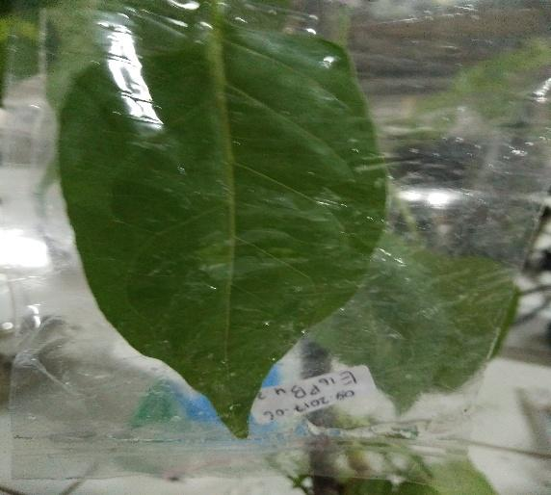 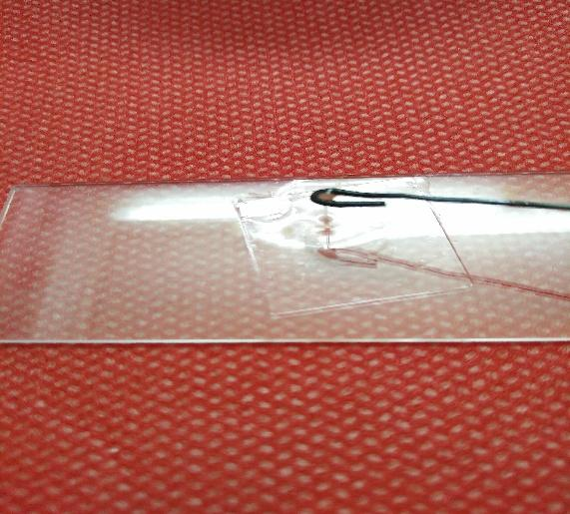

b.

a.

Figure 1. Hypersensitive Test and Gram Test, (a) isolate is injected on the leaves at four o'clock (*mirabillis jalapa);* injection was performed on the leaf repeating area (b) gram test performed on isolates using 3% KOH solution.

Table 1. Isolate Code Rhizobacteria and Endophytic Bacteria EndophyticEndophytic

|  |  |  |
| --- | --- | --- |
|  | **Rhizobacteria** | **bacteria** |
|  | RZ1PB1.3 | E2 PB1.1.1 |
|  | RZ1PB1.4 | E15PB3.1.2 |
|  | RZ1PB1.2 | E16PB.B2.1.1 |
|  | RZ2PB2.5 | E1 PB2.1.2 |
|  | RZ1PB1.5 | E1 PB2.1.1 |
|  | RZ4PB16.B3.1 | E2 PB5.1.1 |
|  | RZ2PB2.4 | E1 PB4.2.1 |
|  | RZ2PB2.2 | E2 PB1.2.2 |
|  | RZ4PB16.B5 | E1 PB3.1.1 |
|  | RZ5PB15.A2 | E16PB.B3.1.2 |
|  | RZ4PB16.B2 | E16PB.B4.1.1 |
|  | RZ3PB16.1.1 | E16PB1.1.2 |
|  | RZ2PB2.3 | E16PB2.2.1 |
|  | RZ2PB2.5 | E1 PB5.1.2 |
|  | RZ4PB16.B3.2 | E1 PB1.2.2 |
|  | RZ4PB16.2 | E2 PB2.1.1 |
|  | RZ3PB16.3 | E2 PB2.1.2 |
|  | RZ4PB16.B4 | E15PB4.1.1 |
|  | RZ3PB16.1.2 |  |

In this study all isolates showed a negative hypersensitive reaction (-) so that all isolates of 19 isolates were used for the next step. endophytic bacteria obtained all isolates showed a negative reaction (-) so that all isolates can be used for the next stage. While for endophytic bacteria isolate, all isolates showed negative reaction (-) so that all isolates could be used for the next step (Table 1.).

**Plant Height**

From 19 rhizobacterial isolates given can increase the height of seedlings of oil palms. isolates RZ2PB2.2 have better effectiveness in increasing plant height among other isolates compared without giving rhizobakteri ie 20.95%. As for the introduction of endophytic bacteria, the highest average yield was found in the treatment of the isolate codes E1 PB2.1.1, which is 25.5 cm and has the highest effectiveness of 19.54%. This indicates that the isolates E1 PB2.1.1 introduced in oil palm seeds are instrumental in assisting in higher plant growth seen with higher effectiveness compared to controls.

**Diameter**

The average diameter of crops found in isolates RZ2PB2.2 is 3,12 cmwith an effectiveness value of 36.24%. While the average diameter of the highest plant endophytic bacteria found inE1 the NT2.1.1 is 0.79 cm by 43.63% effectiveness value that indicates a significant increase stem diameter when compared to other isolates of endophytic bacteria and has a value that is equal to E1 PB3.1.1 andE1 PB2.1.2 was 0.78 cm with a value of 41.81% effectiveness.

**Total of Leaf**

Observations of rhizobacterial isolates, total of leaf in the treatment of RZ3PB16.1A is 4,00 strands. While the average number of highest from E1 PB2.1.2 and E1 PB1.2.2 are 4 strands. Provision of endophytic bacteria isolates of E1 PB2.1.2 andE1 PB1.2.2 bacteria is the best in view of the value of the effectiveness of 33,33% compared with administration of other bacteria.

**Leaf Area**

The average leaf area of ​​oil palm seedlings ranged from 14,13 cm2 - 34,79 cm2 with effectiveness value 60,54%. While the highest average is in the treatment of endophytic bacteria with the code of isolate E16 PB.B2.1.1 is 61.62 cm with the effectiveness value of 22.01%.

**Root Length**

In the rhizobacteria isolates RZ2PB2.2is relatively better that is 32.01 cm, with effectiveness value 42.14%. This is shown in the plant with the highest average endophytic bacteria found in treatment with isolates codeE16 PB.B 4.1.1 Eand2 PB 2.1.2 which is 36.24 cm, 36.00 cm with a value ofeffectiveness 23.47%and 22, 65%.

**Ratio of Root Canopy**

Ratio relatively high canopy ratio in RZ2PB2.3 was 2.93 g with the highest effectiveness value compared with no treatment ie 17.67%. The highest average was in the endophytic bacteria treatment with the code of isolate E2 PB1.1.1that is 5.49 g with the effectiveness value obtained for 118.72%.

**Conclusion**

The final conclusion is that rhizobakteri code RZ2PB2.2 and endophytic bacteria E1 PB2.1.1 can provide the best growth in *pre Nursery.*

**Acknowledgement**

The authors would like to thank all those who have participated in the writing of this research.

**References**

Alexander, M. 1977. Introduction to Soil Microbiology. 2nd ed. John Wiley and Sonc Inc. New York.

Bappeda Sumbar. 2000. Sumatera Barat dalam Angka. Kerjasama Bappeda Tkt 1 Sumatera Barat dengan Kantor Statistik Tkt 1 Sumatera Barat Padang. 596 hal.

Badan Pusat Statistik (BPS). 2017. Perkembangan Industri Kelapa Sawit di Indonesia. Gramedia. Jakarta.

Direktorat Jendral Perkebunan. 2017. Kebijakan Pengembangan Kelapa Sawit Berkelanjutan. Makalah disampaikan pada Seminar Impleentasi RSPO di Indonesia. Jakarta, 10 Februari 2017.

GAPKI. 2013. Dinamika Dan Transformasi Industri Minyak Sawit Indonesia. Jakarta.

Joseph B.,Njan, R.P.R danLawrence, R. 2007. Charecterization of Plant Growth Promoting Rhizobacteria Associated with Chickpea (*Cicerarietinum* L.).J. Plant Production1(2):141-151.

Kementrian Pertanian. 2014. Outlook Komoditi Kelapa Sawit. Pusat Data dan Sistem Informasi Pertanian Sekretariat Jendral. Kementerian Pertanian. Jakarta

Mangoensoekarjo, S. 2007. Manajemen Agribisnis Kelapa Sawit. Gadjah Mada University Press.Yogyakarta.

Purwanto, U.M.S., Fachriyan H.P., Maria B. 2014. Isolasi Bakteri dari Tanaman Sirih Hijau ( *Piper betle* L.) dan Potensinya sebagai Penghasil Senyawa Antibakteri Current Biochemistry, 1(1), 51–57.

Pusat Penelitian Kelapa Sawit. 2008. Deskripsi Kelapa Sawit DxP Simalungun. Medan.

Suhandono, S., and Utari, I. B. 2014.Isolation and Molecular Identification of Endophytic Bacteria from the Arils of Durian (*Durio zibethinus Murr*) var. Matahari. Microbiology Indonesia, 8(4), 161–169.

Supramana, P., Supriadi, L dan Harni, R. 2007. Seleksi dan Karakterisasi Bakteri Endofit Untuk Mengendalikan Nematoda Peluka Akar (*Prathylenchus brachyurus*) Pada Tanaman Nilam.Laporan Hasil penelitian Institut Pertanian Bogor dengan Litbang Pertanian Proyek KKP3T.

Soesanto, L,. 2008. Pengantar Pengendalian Hayati Penyakit Tanaman. Jakarta : Rajawali Pers. 574 Hlm

Tim Survei faperta Unand 1986. Laporan Survei Kapabilitas Tanah dan Penggunaan Lahan Daerah Rawa Anai Padang Pariaman Sumatera Barat Padang. 160 hal

Yanti. Y., Habazar, T., Resti, Z dan Suhailita, D. 2013. Penapisan Isolat Rhizobakteri dari Perakaran Tanaman Kedelai yang Sehat Untuk Pengendalian Penyakit Pustul Bakteri *(Xanthomonas axonopodis Pv. glycines)*. Jurnal HPT Tropika 13(1):24-34.

Trivedi, P.C, S. Pendey, dan S. Bhadauri. 2010. Text Book Of Microbiology. Aavishkar Publisheres. India.