RECLAMATION OF COAL MINING USED LAND THROUGH OBSERVATION ON EFFECTIVINESS OF ARBUSCULAR MYCORRHIZAL FUNGI ON CORN PLANTS IN GREENHOUSE

¹Eti Farda Husin, ²Ujang Khairul, ³Zelfi Zakir and ⁴Oktanis Emalinda
¹ Departement of Soil, Faculty of Agriculture, Andalas University
²Departement of Plants Disease Pests, Faculty of Agriculture, Andalas University
³Departements of Social Economics, Faculty of Agriculture, Andalas University
⁴ Departement of Soil, Faculty of Agriculture, Andalas University

Abstract
Mining activities cause detrimental effects on environments and until now there has not been a maximum effort to rehabilitate the condition. When this condition is not improved very soon, it will cause disaster for human. Mining activity is often started with land clearing and its vegetation, digging soil layers and coal materials, and piling up of soil that can cause negative impacts on environments.
To improve the environment impact right away there should be an effort to be implemented that can support sustainable agricultural development in Indonesia. One method is application of natural fertilizer like Arbuscular Mycorrhizal Fungi (AMF) on corn as a host plant.
The objective of research was to determine optimal dose of AMF that could give the highest growth and yield of corn using soil from coal mining used land in Sumatera Barat. The research was done in a greenhouse and laboratory. The result indicated that application of AMF inoculants with a dose of 40 gr/pot either in mono or multispores could increase corn yield in coal mining used land.

INTRODUCTION
Mining used lands in Indonesia are diverse and abundant, one of them is in Sawah Lunto, West Sumatera. Most of lands after exploitation for coal mining are left without cares, mainly in around mining lands. When the lands are not rehabilitated, it will cause the lands unproductive and ruin their ecosystems.
To rehabilitate the environmental detriments right a away, appropriate reclamation series must be implemented in the degraded lands. These activities do not only improve the lable land condition and reduce soil erosion, but in a long term can improve micro climate condition in areas of revegetation. Using appropriate prereclamation method, one of them is implementing Arbuscular Mycorrhizal Fungi (AMF), can increase the growth of revegetation in mining used lands.
AMF is used in a form of inoculants having active living organisms which function to facilitate the availability of nutrients in soil for plants (Simanungkalit, 2000). AMF also facilitates water for plants and improves agregation and soil stability. Water absorption by AMF in water dried condition can occur through its hypha and hypha can penetrate soil micro pores which can not be reached by plant roots. Indirectly, the existence of AMF in plant roots can influence the soil aggregate condition which in turn increase soil ability to retain water. Some researches reported that AMF could increase root hydrolic activity, water and nutrients transport to plant root (Husin,Auzar & kasli, 2002)
Mycorrhyza is defined as symbiotic relationship between fungi and plant because plants obtain more nutrients through root morphological changes inside and outside roots by forming new structure. This new structure enables plants to tolerate the problem of growing factors so that the plants can still grow well. Based on this ability, AMF has a great potential to be developed in plant agronomy mainly in critical lands such as coal mining used lands.
Important factors to be considered in AMF inoculants propagation are compatible host, growing location, and environment. These factors need to be considered because AMF is obligate and its needs for the factors are not always the same. According to Bagyaraj (1992), in propagation of AMF, inoculants must have high infectivity and effectivity, and there there must be specific host root colonization. All plants are potential to be infected but infectivity and effectivity are different in each of association of host and AMF.
Bakhtiar (2002) stated that host selection in pot culture gave much influence on sporulation and root infection. The first consideration is selection of host plant which is tolerant to greenhouse environment. Indeed, AMF does not select specific host but AMF is able to symbiote with most plants. Some reported that 90% of AMF could symbiote with plant roots including Angiospermae, Gymnospermae, Pteridophyta and Briophyta, but infectivity and effectivity were different in each host. Only appropriate host of AMF gives symbiotic response and maximum colonisation (Bagyaraj 1992). Corn plants are used mostly for propagation of AMF inoculants but the right dose of AMF inoculants when applied at corn plants using soil from coal mining used land, has not been studied yet.
This research was aimed at determining the best dose of AMF inoculants for corn plant growth using coal mining used land.

MATERIALS AND METHODS

The research was conducted in laboratory and greenhouse. The first step of experiment was identification of AMF spores in laboratory found dominantly. The second step was application of AMF spores in greenhouse by applying AMF spores on corn plants in the form of single and multi spores with different doses.
The research was arranged in Completely Randomized Design. There 5 (five) treatments in a greenhouse experiment : (A). Control (no AMF), (B). 20 gr AMF inoculants of single spores, (C). 40 gr AMF inoculants of single spores, (D). 20 gr AMF inoculants of multi spores, and (E). 40 gr AMF inoculants of multi spores . Data were analized with F test and further with DNMRT at 5% significance level.
Laboratory experiment was started by taking soil samples from coal mining used land. There were 4 points of location (north, south, east, and west parts) in Sawahlunto city in West Sumatera. In every point of location, soil samples were taken from plant rhizosphere more or less 2 kg for AMF spore observation.
AMF spores were isolated from soil samples based on wet screen method with the following prosedure: (a). 100 gr of soil sample was placed in a beaker containing 0.5 L aquadest and then stirred evenly, (b). The soil mixture was then screened with a series of screeners size, 410; 125 and 45 mesh, (c). materials in screener was placed in a tube and then was centrifused for 5 minutes, (d). Solution in a surface of tube was discarded and the rest was placed in a test tube containing 60% sucrose as soil solution then it was centrifused for 3 minutes, (e). Supernatan in the tube was centrifused and washed then screened with 45 mesh screener, (f). Materials in screener (AMF spores) was placed in a petridish by the aid of aquadest spray and then spores were observed and identified under microscope, (g). Identification was done for morfological characteristics of spores, form, shape,color, and size based on guide book of Hall and Fish (1979). Identified spores were propagated in single or multi spores. Spores were screened first to get good ones for soil and plants, efficient in using fertilizers, effective in controlling pests and diseases and able to overcome the toxic of heavy metal like Al (allumunium) for plants.
Propagation of inoculants was done in 2 steps, in laboratory and in greenhouse. Propagation of single spore inoculant was done directly as propagation, while the one for multi spores did not need specific skill because it could be done by pouring all stock spores from petridish to plant seedlings that just germinated in planting media of sterile sand.
AMF propagation was done by placing 3 kg of sterile sand into a pot and then put the AMF inoculants obtained into the same pot by layers between sand and inoculants.

Isolation of AMF spores from soil is presented in the scheme:
Add water and centrifused for 5 minutes at 200 rpm
Soil was washed with water

Dirts were discarded together with supernatant
500 µm
(roots etc.)

Precipitated pellet was added with 50% surose and centifused for 1 minute at 2000 rpm
300 µm
(A)

Pellet was discarded
106 µm
(B)

Supernatant was washed using 45 µm screener to release sucrose before screening with screening paper
53 µm
(C)

Figure 4. Scheme for isolation of AMF spores from soil Spores on screening paper

RESULTS AND DISCUSSIONS
- Observation on corn plants (Zea maysL) in greenhouse

Results of observation on AMF spores in plant rhizosphere in coal mining used lands were presented in tabel 1. Observation showed that application of higher dose of AMF inoculants (40 gr) resulted in higher plant height compared to other treatments. In propagating the AMF inoculants, things that need to be considered are host compatibility, growing media, and environment because AMF is obligate and each does not have the same need for the factors.

Table 1. Arbuscular Mycorrhizal Fungi (AMF) oncorn plant in a greenhouse
Plant | Dose of AMF (gr) | Plant height  (cm) | Number of leaves
Corn | 0 inoculant | 108,75 | 14,00
 | 20 gr (single spore) | 209,20 | 16,75
 | 20 gr (multi spores) | 185,33 | 16,50
 | 40 gr (single) | 209,30 | 16,20
 | 40 gr (multi spores) | 171,60 | 15,00

- Number of spores, Percentage of AMF infection and root fresh weight of corn plant (Zea mays L)
Number of inoculants applied indeed did not indicate number of spores found in corn hostplant at harvest time. Even at the treatment without AMF inoculants, spores were still found in planting media. In general, in 100 gr of corn planting media there were 1 – 8 spores found. Percentage of AMF infection in corn roots was 20-80% (Table 1).

Table 1. The effect of inoculants on number of spores, percentage of infection and root fresh weight of corn plant (Zea mays L)
No | Treatment | No. spores/100 g soil media | Corn root fresh weight (g) | AMF infection in corn root (%)
1 | Control (No AMF) | 1 | 9,12 | 20
2 | 20 g single spore inoculant | 3 | 21,30 | 20
3 | 40g single spore inoculants | 8 | 12,20 | 60
4 | 20 g multi spores inoculants | 1 | 13,99 | 40
5 | 40 g multi spores inoculants | 4 | 20,27 | 80

Number of AMF spores from various AMF found in corn plant media are presented in Figure 1. This figure shows there are spores living singly or in cluster. Figure 1c shows spores in cluster but the rests are single spore. For better information Figure 1 could be compared with Figure 2 and 3.

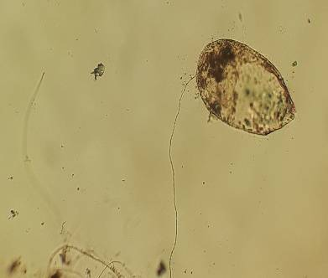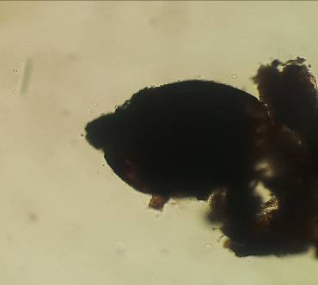
a
b
c
Figure 1.Scutelospora sp
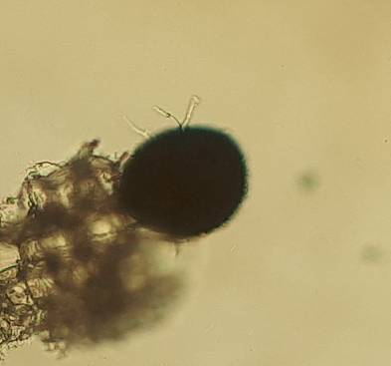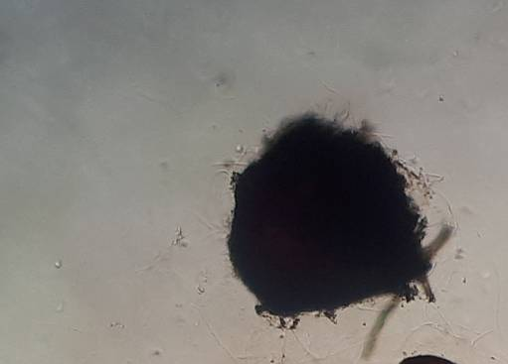
e
d
Figure 1.Glomus sp

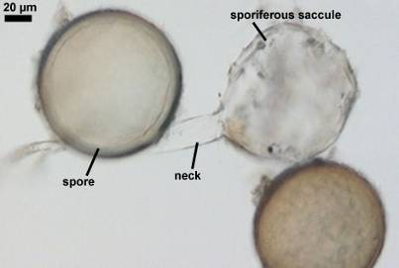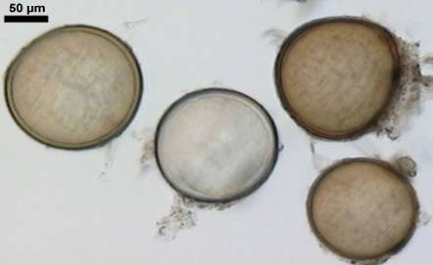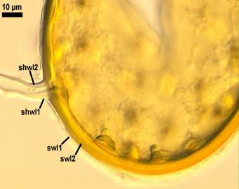

Figure 2. Acaulospora scrobiculata and spores from Glomus etunicatum (on the right) (Sources;Schenck & G.S. Sm. 2007; Becker & Gerd. 2005).

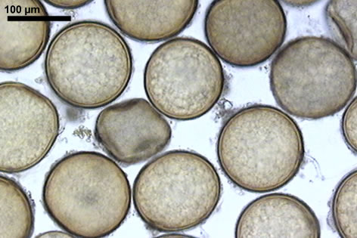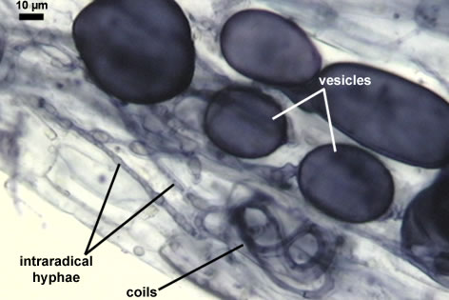

Gambar 3. Glomus claroideum/Glomus claroideum-34-1-bf-r-1.psd and its infection in root of P. lanceolata(Sumber;Schenck & G.S. Sm. 2007).
Percentage of AMF infection on corn host plant showed the effectivity of AMF having symbiosis with its host plant. The higher the infection level in roots means AMF has a good association with host plant. Table 1 showed that there was relationship between number of spores in roots and AMF infection in roots. The highest infection of AMF occurred in corn roots applied at 40 g inoculants of G. etunicatum. When given multi spores, infection was not high. This was caused by the occurrence of competition between AMF in corn roots. The low infection can also caused by the effect of manure applied.
The ability of AMF in increasing plant growth has been proven even in marginal lands. Straker et al.,(2010) proved that cassava plants which grew well in low fertility of soil could still grew in a very poor land or marginal land. This was caused by the occurrence of Glomus manihotis which was strong invasive, effective and grouped as AMF which was competitive and able to increase P transport and plant biomass. Further, according to Yokoyama, (2002); Mayumi & Mitsuro (2005); Bhartia et al., (2016) AMF was fungi which was able to have symbiosis with many plant species. AMF is able to increase plant growth by improving nutrient transport and soil water. However, there is competition between AMF inoculants and natural AMF.Liu et al., (2015) indicated that Glomus versiforme could increase plant growth and resistance against toxicity by heavy metal which contributed in phytoremedy. This was proven in potato plant resistance on Ca toxicity because there was an increase in soil phosphatase acid. Glomus versiforme increased significantly DTPA (phytoavailable) from concentration 25 to 50 mg Ca kg⁻¹ in soil. Lanfranco, Garnero, & Bonfante(1999) reported that Glomus versiforme had gen kitin sintase which helped the growth of host plant by adding P. Takanishi, Ohtomo, Hayatsu, & Saito, (2009) stated that anorganic phosphate was absorbed from soil by radical extra hypha, then transformed into polyphosphate, translocated into intraradical hypha in micorrhizal root and supplied to plants through hydrolisis in arbuscula.

Addition of GRSP (Glomalin related soil protein) reduces soil organic in overcrowded soil participle and increases soluted organic matter concentration in solution, which dominates the mechanism of phenanthrene GRSP availability. The result gave idea about the role of GRSP in Polycyclic aromatic hydrocarbon (PAH) availability. PAH is carcinogenic that can be absorbed by plants, and plants are eaten by people and animals, so that they involve in food chain that is dangerous for health. For this reason, the role of GRSP is important in recovering contamination by PAH. Glomalin is produced by hypha of AMF which is four times as humat acid concentration (Gao, Zhou, Ling, Hu, & Chen, 2017).

Plants have cellular mechanism which may involve in detoxification of heavy metal, thus the plants have better tolerance to it. Colonization of AMF is one of the mechanisms. AMF of G. etunicatum is tolerance on toxicity of Zn by increasing activity of some antioxidant enzymes on plants .(Farshian, Khara, Parviz. ,2007).
Infection ability of AMF in general is low, around 20%, except infection of G. Etunicatum that can reach 80%. Condition of infection is presented in Figure 3.
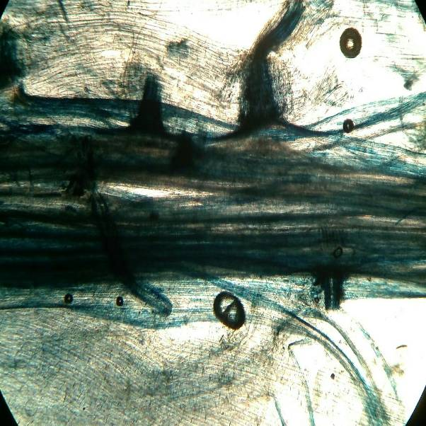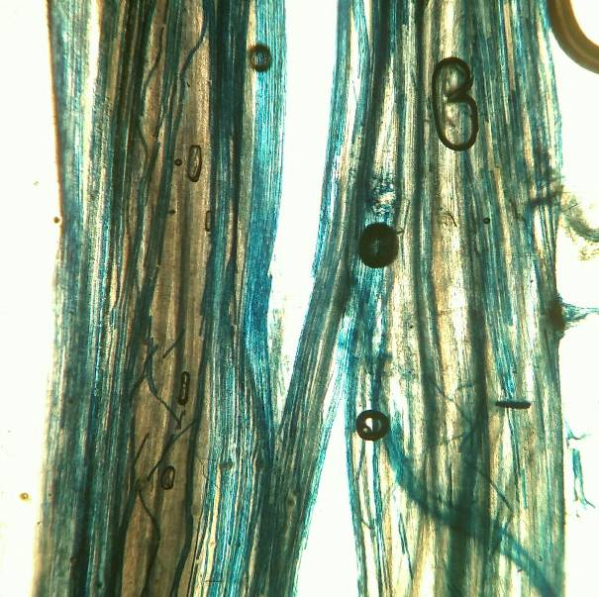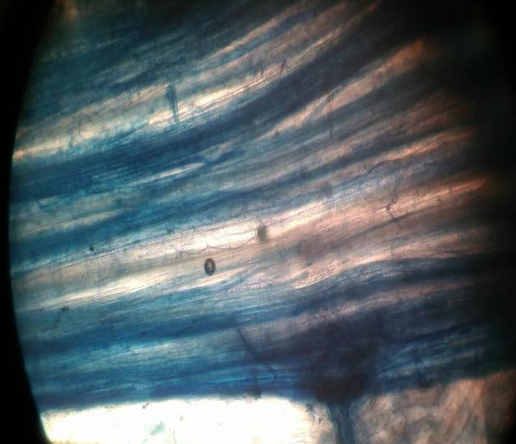.
c
d
b
a

Figure 3.a-d (a=40 g inoculants G. Etunicatum, b= 40 g inoculants multi spores, c=20 g inoculants multi spores, d=40 g inoculants G. Luteum). Corn roots infected by G. Etunicatum, G. Luteum(single spore) and b-c (multi spore).

Infection of AMF in roots is not always effective. Application of single spore couls be much better than multi spores application. According to Tchameni et al., (2011) Gigaspora margarita and Acaulospora tuberculata mixed with saprofit fungi of Trichodermaasperellum (multi spores) showed better effects compared to single application of fungi. Application of single spore could increase nutrient absorption and growth of cocoa seedlings. However, multi inoculation of AMF on cocoa seedlings with T. asperellum does not always have positive effect on plants. Inoculation on leaves showed variation among treatments with the lowest disease index (highest resistance) occurred on plants inoculated with AMF or T. asperellum only. This point relevant with great synthesis amino acid and fenolik compound of salutary leaf and septic, to manifest the metabolit involved resistance disease
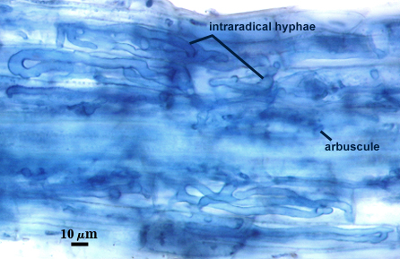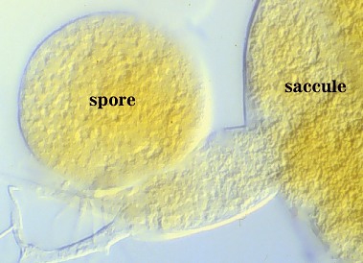
Figure 7. Structure of AMF in corn roots (West Virginia University, 2007)

Malekzadeh, Khara , Farshian . (2007), reported that tomato plants inoculated with AMF G.etunicatum given Co up to toxic level, showed increases in all growth parameters compared to plants without AMF inoculation. Concentration of P correlates with formation of chlorophyl and increased sugar. Increased concentration relates to AMF infection.
C. Result of soil analisys from greenhouse trial after treatment.
Observation and soil analysis were done in laboratoty after given treatment of 20 gr multi spores, 20 gr single spore, 40 gr multi spores, 40 gr single spores and control (no AMF) Data from soil analysis is presented in Table 4.

Table 4. Results of soil analysis after inoculation with Arbuscular Mycorrhizal Fungi (AMF)
No | Rata-rata | pH | N(%) | C org  (%) | Al | Ca | Mg | K | Na
1  2  3  4  5 | 0  20 gr multi  20 gr single  40 gr multi  40 gr single | 5,87  6,80  7,04  6,79  6,50 | 0,46  0,62  0,49  0,54  0,47 | 3,88  4,20  4,38  4,47  3,78 | TU  -  -  -  - | 0,48  0,66  0,70  0,78  0,84 | 0,99  1,02  1,12  1,00  1,12 | 0,25  0,32  0,36  0,38  0,43 | 0,45  0,46  0,53  0,47  0,55

Treatment with AMF affected soil pH in which pH increased from 5.87 (control) to 6.80 at the dose of 20 gr multi spores and 6.79 at the dose of 40 gr multi spores. It also occurred on single spore treatment, soil pH increased up to 7.04 at dose of 20 gr single spore and little decreased to reach 6.5 at the dose of 40 gr single spores.
Application of multi spores showed a great effects on soil Nitrogen content. There was an increase in plant N-total as much as 0.16 % and 0.08%, while application of single spore tended to have no effect on soil N-total content.
Application of AMF increased C-organic content in soil reaching up to 4.47 % (40 gr multi spores), 4.20% (20 gr multi spores) and 4.38 % (20 gr single spore). However, increased dose at 40 gr single spore decreased soil C-organic.

Content of soil base kation
Application of single and multi spores of AMF caused an increase in soil base kation, Ca, Mg, K and Na. Ca content in soil increased 0.36 me/100gr at dose of 40 gr single spores, and at dose of 40 gr multi spores the increase was 0.30 me/100gr. Content of Mg in soil increased as much as 0.13 me/100gr at dose of 40 gr single spore. Soil potassium also increased 0.18 me/100gr at dose of 40 gr single spore, while at dose of 40 gr multi spores the increase was 0.13 me/100gr. Soil Natrium increased slightly i.e. 0.1 me/100gr (40 gr single spore), while applying multi spores of AMF almost showed no effect on soil Na content.

Refferences

Bagyara.D.J. 1992.Ecology Of Vesicular-Arbuscular mycorhizae. P. 3-34 in D.K.. Arora, B.Rai,K.G. Mukerti and G.R. Knudsen (Ed.) Handbook of applied Mycology, Soil and plants. New York : Marcel Dekker.
Bakhtiar.Y.2002. Selection of vascular mycorrizha (VAM) fungi, host plants and spore numbers for producing inoculum. J. Biosains dan Bioteknologi Indonesia 2 (1); 36-40
BeckerW.N. & Gerd. 2005. Glomus etunicatum.http://www.zor.zut.edu.pl/Glomeromycota/ Glomus%20etunicatum.html. akses tanggal 2 Agustus 2017.
Bhartia, N., Barnawala, D., Shuklaa, S., Tewarib, S. K., Katiyarb, R. S., & Kalra, A. (2016). Integrated application of Exiguobacterium oxidotolerans, Glomus fasciculatum, and vermicompost improves growth, yield and quality of Mentha arvensis in salt-stressed soils. Industrial Crops & Products. https://doi.org/10.1016/j.indcrop.2015.12.021
Farshian S¹, Khara J, Parviz M.. 2007. Effect of arbuscular mycorrhizal (G. etunicatum) fungus on antioxidant enzymes activity under zinc toxicity in lettuce plants.Pak J Biol Sci. 2007 Jun 1;10(11):1865-9
Gao, Y., Zhou, Z., Ling, W., Hu, X., & Chen, S. (2017). Soil Biology & Biochemistry Glomalin-related soil protein enhances the availability of polycyclic aromatic hydrocarbons in soil. Soil Biology and Biochemistry, 107, 129–132. https://doi.org/10.1016/j.soilbio.2017.01.002.
Lanfranco, L., Garnero, L., & Bonfante, P. (1999). Chitin synthase genes in the arbuscular mycorrhizal fungus Glomus versiforme : full sequence of a gene encoding a class IV chitin synthase. FEMS Micribiology Letter, 170, 59–67.
Husin E.F, Azwar & Kasli . 2002. Mikoriza Pendukung Pertanian Berkelanjutan. Universitas Andalas. Padang.
Liu, H., Yuan, M., Tan, S., Yang, X., Lan, Z., Jiang, Q. Jing, Y. (2015). Enhancement of arbuscular mycorrhizal fungus ( Glomus versiforme ) on the growth and Cd uptake by Cd-hyperaccumulator Solanum nigrum.Applied Soil Ecology, 89, 44–49. https://doi.org/10.1016/j.apsoil.2015.01.006
Malekzadeh P, Khara J, Farshian S. 2007. Effect of Arbuscular Mycorrhiza (Glomus etunicatum) on some physiological growth parameters of tomato plant under copper toxicity in solution. Pak J Biol Sci. 2007 Apr 15;10(8):1326-30.
Mayumi, W. A. C., & Mitsuro, K. (2005). Interaction between arbuscular mycorrhizal fungus Glomus mosseae and plant growth promoting fungus Phoma sp . on their root colonization and growth promotion of cucumber ( Cucumis sativus L .). Mycoscience, 3(3), 201–204. https://doi.org/10.1007/s10267-005-0230-3
Schenck, N.C. & G.S. Sm. 2007.Glomus claroideum.http://www.zor.zut.edu.pl/ Glomeromycota/Glomus%20claroideum.html. akses tanggal 2 Agustus 2017.
Straker, C. J., Hilditch, A. J., & Rey, M. E. C. (2010). Arbuscular mycorrhizal fungi associated with cassava ( Manihot esculenta Crantz ) in South Africa. South African Journal of Botany, 76(1), 102–111. https://doi.org/10.1016/j.sajb.2009.09.005
Takanishi, I., Ohtomo, R., Hayatsu, M., & Saito, M. (2009). Soil Biology & Biochemistry Short-chain polyphosphate in arbuscular mycorrhizal roots colonized by Glomus spp .: A possible phosphate pool for host plants. Soil Biology and Biochemistry, 41(7), 1571–1573. https://doi.org/10.1016/j.soilbio.2009.04.002
Tchameni, S. N., Ngonkeu, M. E. L., Begoude, B. A. D., Nana, L. W., Fokom, R., Owona, A. D., Kuaté, J. (2011). Effect of Trichoderma asperellum and arbuscular mycorrhizal fungi on cacao growth and resistance against black pod disease. Crop Protection, 30(10), 1321–1327. https://doi.org/10.1016/j.cropro.2011.05.003

West Virginia University, 2017.Acaulospora spinosa (reference accession WV861A). http://fungi.invam.wvu.edu/the-fungi/classification/acaulosporaceae/acaulospora/ spinosa.html

Yokoyama, K. (2002). A molecular marker diagnostic of a speci ¢ c isolate of an arbuscular mycorrhizal fungus , Gigaspora margarita. FEMS Micribiology Letter, 212, 171–175.

