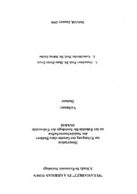
"Fleamarket" in a German Town: A Study in Economic Sociology
Sampul Depan
Damsar
Cuvillier, 1998 - 183 halaman

https://cuvillier.de/uploads/preview/public_file/7393/3897121875.pdf

